1. Introduction
   1. **What is Machine Learning?**

Today, we are surrounded by ‘data’ anywhere we go. Living in a world dominated by the technological advancements of computers, it should be a very important job for everyone to understand what data is and how it’s been used today.

There have been, undoubtedly, many groundbreaking discoveries that have been made and researched during the 21st century; however, just one seems to come out on top, that is AI. In our generation, data is being created practically everywhere. Whether you are just shopping online for new clothes, uploading videos to the internet, creating a new account on a website or even just browsing the web will generate data. Most of you reading this probably already knew this, but, the more interesting question to ask is *How is this data being used especially in AI?*

Let’s think about an online clothing store for example. When we are usually browsing for clothes it’s common for us to look for specific types or categories of clothing. Whether it’s a skirt, t-shirt or a jumper it doesn’t matter, but now, when visiting the same online website again you may have experienced being bombarded with recommendations and other clothing that you may have possible interests in.

From the moment that you started browsing clothes and to the moment that you possibly bought those clothes, data is always being generated. Using this data within Ais and machine learning algorithms companies can make educated guesses as to what you might be interested in to buy next. Additionally, it’s not only clothing stores that are using this, it’s expected that most industries will be using Ais from now on. It’s actually harder to list the names of industries that won’t be affected by AI compared to ones that will be. This is how AI and data are very heavily related and used within the world today.

In this book, we aim to teach you the fundamentals of machine learning. By exploring the mathematics of some machine learning algorithms that are used in common problems and also learning how these algorithms are created and applied in coding you’ll be able to grasp what machine learning is.

Hopefully, by the end you’ll have enough knowledge about machine learning to start learning deep learning.

1. Supervised Learning

2.1 Introduction

Today, there are many different algorithms used to solve machine learning problems; however, the most common are within the family of **supervised learning** algorithms. In this chapter not only will we learn and understand the fundamentals of supervised learning but we’ll also take look at the most basic types of problems that we come across in supervised learning. By the end we will also apply our example in coding form to enhance our understanding of how machines “learn”.

Supervised learning, as the name states, is where we specifically tell or teach the computer how to solve a certain problem. In other words, the computer will predict or determine the outputs of a certain problem by looking at past data that we provide. To put it in a more mathematical format, supervised learning is where you will use an algorithm to map values of the input (x) to the output (y). We all know that in a 2-dimensional graph that the values of our output (y) depend on the values of the input (x). When using automated graphing programs such as Excel, we can make the program put a line of best fit into our data. This is one of the techniques that supervised learning may do and thus by using the line it can predict the output (y) for the values of input (x) that aren’t within the original data set. This is what is meant by saying that a machine ‘learns’.

Additionally, the data set originally provided to the ‘machine’/program is referred to as the training set. In this book we will only scratch the surface of supervised learning as we won’t be covering the whole list of possible supervised learning problems that may show up in the real world, but hopefully, you will be able to get a great understanding of the basics of how a machine may ‘learn’ and this will lead you into more complex ideas within future. Now, enough of that and let’s go check out some problems that may require us to use a supervised machine learning algorithms.

2.2 Regression Problems

Regression problems are where the output variable is real or continuous and non-discrete. This means that the outputs cannot be specifically classified into certain types or classes of data. Some examples include price, temperature, weight any many more. You have probably already noticed, but this is an extremely common type of problem that we as humans come across in the real world on a daily basis. Regression models are commonly divided up into 2 types, simple or complex. Simple is where the outputs only depend on one variable only, meanwhile the outputs of complex regression problems will depend on multiple variables. These can both be solved linearly or non-linearly (polynomials).

Now let’s dive into an example, let’s say that there is a computer called ML101. The price of ML101 depends on how many people are interested in actually buying this system. Now assume that Table 1 below is the training set gathered for the relationship between the price and popularity of ML101 and that you want to know the price of it when there are 1000 people interested in the product.

Table 1: Regression problem training set

|  |  |
| --- | --- |
| Number of people interested in ML101 (100’s) | Price of ML101 ($) |
| 3 | 500 |
| 8.9 | 900 |
| 12 | 1050 |
| 17 | 1300 |
| 20 | 1250 |
| 25 | 1400 |
| 31.6 | 1500 |
| 51.2 | 1550 |

Table 1: No. Of people interested in ML101 vs Price of ML101

Figure 1: No. Of people interested in ML101 vs Price (Linear)

Now what a machine learning algorithm may do, as mentioned above, is learn by placing a line of best fit into the data/graph and predicting the results by reading off of it as shown above in figure 1. Now going off of what figure 1 has produced the learning algorithm will estimate that the price will be around $960 when there are 1000 people interested in ML101. However, you can probably notice from figure 1 that a linear line is probably not the best choice of algorithms for our dataset.

Thus we can do much better with a polynomial in this case, possibly a quadratic equation.

Figure 2: No. Of people interested in ML101 vs Price (Polynomial degree 2)

In the case of figure 2 above, we have used a learning algorithm that applies a polynomial function of degree 2 to our training set, thus when taking a look at illustration, at 1000 people interested the price of ML101 is estimated to be at around $1000.

Furthermore, comparing the two different learning algorithms used in this example (linear and quadratic), it’s immediately noticeable, that there is a difference of $40 within the predictions. Although in this example the difference wasn’t very large, we can quickly see that choosing the right or the most appropriate algorithm for certain datasets plays a critical role in solving machine learning problems correctly, or at least producing results that are in the most accurate form possible. This is much more apparent when training sets are much larger and possibly have drastic changes.

2.3 Classification Problems

Aside from regression problems, we also have classification problems. The output of classification problems are pretty much the complete opposite of regression problems. In regression problems we found out that the output variable must be continuous, however in classification problems the output variable is discrete. This means that outputs can be categorized into certain types or classes. For example, assume there is a training set showing both students’ total time studied for a test and whether they passed or failed.

|  |  |
| --- | --- |
| Total time of study for test | Pass or Fail |
| 1 | Fail |
| 2 | Fail |
| 5 | Fail |
| 10 | Fail |
| 16 | Pass |
| 17 | Fail |
| 22 | Pass |
| 25 | Pass |

Table 2: Classification problem training set

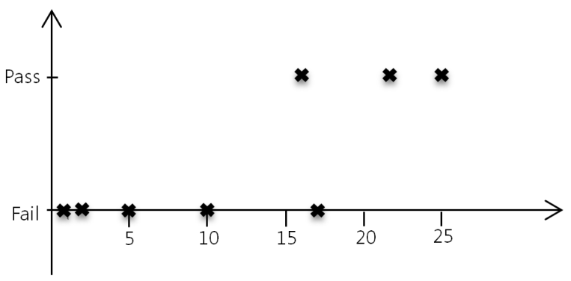

Figure 3: Classification problem training set 1 plot 1

We’ll discover in chapter 5 that we will use a logistic regression algorithm to fit a logarithmic function to the graph and specify a threshold that will determine which class the output belongs to.

2.4 Summary and Exercises

This chapter was mainly focused on a brief introduction to supervised machine learning and machine learning in general. More specifically, we have looked at two main different types of supervised machine learning which are regression and classification. You should now not only know the differences between regression and classification, but also be able to depict which type of supervised learning should be used on a given data set/problem.

Additionally, the main idea of machine learning is to fit a line that is the most optimal to our data. For a machine to do this successfully, they must choose not only the correct position of the line on the graph but also what type of line it should use, as it can make huge differences on the predictions of new incoming data.

In the following chapters we will study how computers can fit the most optimal line/functions. Firstly we will try to understand the mathematics behind it and also implement on code using python.

**Questions:**

1. What is supervised learning?
2. What are types of supervised learning that we briefly look at in this chapter
3. Continuing on from question 2, state the differences between the types that you wrote down
4. State whether the following examples are either a regression or classification type and explain why

* Is this email a spam?
* How many ice-creams will sell when the temperature is 31oC
* Is the following photo a dog or a cat?
* Does this person have cancer?
* What are the prices of houses that are 100 square meters in size

1. Give one example of what a machine learning algorithm may do to predict future values if a data set.

**Answers:**

1. Supervised learning is where we specifically teach the machine how to solve the problem usually by feeding it past data. From this data, the learning algorithm can predict by mapping new values of inputs (x) to outputs (y)
2. Regression and Classification
3. The outputs of regression are continuous while the output is discrete for classification problems.
4. i) Classification, we can categorize the outputs into two types of spam and not spam

ii) Regression, we can assume that due to different temperatures the amount of ice-creams sold will differ. Thus, the number of ice-creams isn’t limited by certain values.

iii) Classification, we can categorize the outputs into two types dogs or cats

iv) Classification, we can categorize the outputs into a yes or no answer where yes means that the person has cancer and no meaning that they don’t.

v) Regression, once again as the prices of houses are limited to certain values

5. It can possibly solve regression problems by fitting a line to the data and predicting future outputs according the line

1. Simple Univariate Linear Regression

3.1 Univariate Linear Regression

Now that we understand what supervised learning and regression are, let’s try and solve a linear regression problem. Note that, linear regression is just an approach for solving problems linearly (**line** of best fit) and because we’re looking at only simple linear regression for the moment we are only dealing with outputs that relate to only one variable. This is also referred to as a univariate linear regression (simple).

Let’s consider the example before in chapter 2 which was a training set that represented the price of a computer named ML101 depending on its popularity. But, before we go any further with linear regression let’s talk about some very important notations that’ll be useful later.

|  |  |
| --- | --- |
| Number of people interested in ML101 in 100s’ (x) | Price of ML101 (y) |
| 3 | 500 |
| 8.9 | 900 |
| 12 | 1050 |
| 17 | 1300 |
| 20 | 1250 |
| 25 | 1400 |
| 31.6 | 1500 |
| 51.2 | 1550 |

Table 3: Price of ML101 Modified

Notations:

x = input (Number of people interested in ML101)

y = output (Price of ML101)

(x, y) = a certain training example (for example (25, 1400) is a training example)

(x(i),y(i)) = ith training example (for example (x(2),y(2)) = (8.9, 900))

m = total number of training example (In table 3, m = 8)

3.2 Cost Function

Figure 3 below shows how supervised algorithms solve certain machine learning problems. In this case we feed the linear regression algorithm our training set that we have collected. Then, the algorithm will produce ‘h’ which is a function also known as the hypothesis that will map the input x, in our case, the popularity of ML101 to the output y (price of ML101).

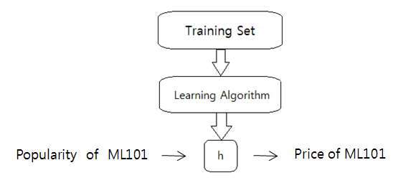

Figure 3: Flowchart of the general process of supervised algorithms

Furthermore, in this example the hypothesis must be a linear function as we’re dealing with a univariate linear regression.

Thus we will represent the hypothesis mathematically as the following:

$$h_{θ}\left(x\right)= θ_{1}x+θ_{0}$$

Where $θ_{1}$, $θ_{0}$ are the gradient and y-intercept respectively. These are also referred to as the **parameters**

Now let’s understand the behavior of this function when changing the parameters by looking the following illustration

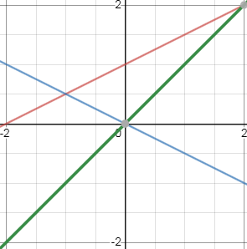:

$$θ_{1}=1 {, θ}_{0}=0$$

$$θ_{1}=0.5 {, θ}_{0}=1$$

$$θ_{1}=-0.5 {, θ}_{0}=0$$

Figure 4: Linear Function Behavior

We can clearly see in figure 4 changing the values of our parameters will change the outcome of the line itself. Thus, we must now ask ourselves “how do we come up with the values of $θ_{1}$, $θ_{0}$ so that the line of best fit is the most optimal?” Well, it turns out that if we want our hypothesis to be the most ‘optimal’ then, we want the values of $h_{θ}\left(x\right)$ to be as close as to the original y values in our training set.

Additionally this becomes a minimization question where we want to minimize:

$$h_{θ}\left(x\right)-y$$

However this value must be squared since we only care about the magnitude of the difference, thus:

$${(h_{θ}\left(x\right)-y)}^{2}$$

And because we must minimize for all values of input/output x and y respectively within the training set so:

$$\sum_{i=1}^{m}{{{(h}_{θ}\left(x^{\left(i\right)}\right)-y^{\left(i\right)})}^{2}}$$

Finally to make the mathematics simpler we will minimize the average difference which ultimately makes the final equation to be:

$$J\left(θ_{0}{, θ}_{1}\right)=\frac{1}{m}\sum_{i=1}^{m}{{{(h}_{θ}\left(x^{\left(i\right)}\right)-y^{\left(i\right)})}^{2}}$$

This equation is also known as the **cost function** or the **squared error function**.

To get a deeper understanding of the cost function let’s assume for the moment that $θ_{1}$ has been fixed and only ${ θ}_{0}$ is just changing. Interestingly, what we find is that plotting the summation of the errors (cost function) on each value of ${ θ}_{0}$ gives us a parabola like the following:

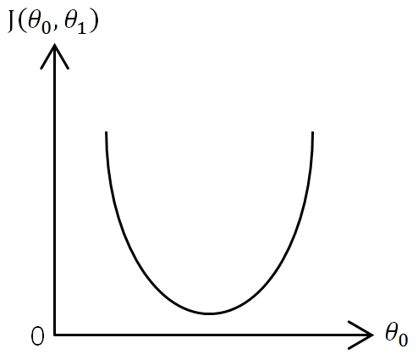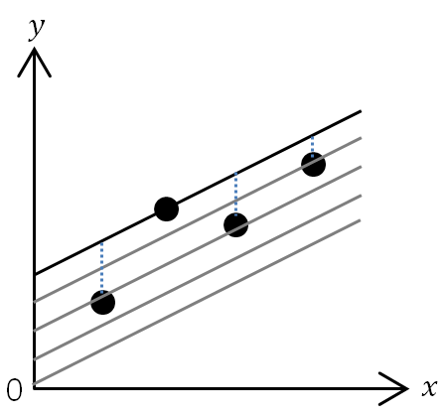

This kind of behavior also happens when we plot the cost function when fixing ${ θ}_{0}$ and only changing $θ_{1}$

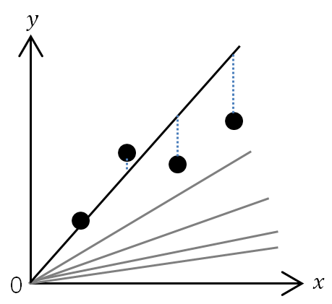

If you’re comfortable with multivariate mathematics you will immediately realize that these are the cross-sections of the cost-function.

Thus when we plot the cost function that depends on the change of both parameters $θ_{1}$ and ${ θ}_{0}$ we get the following graph.

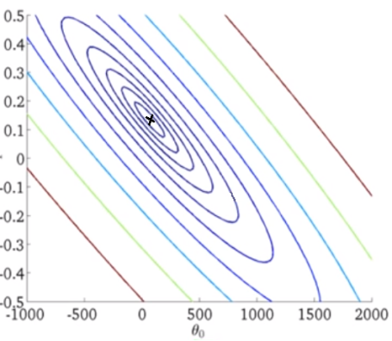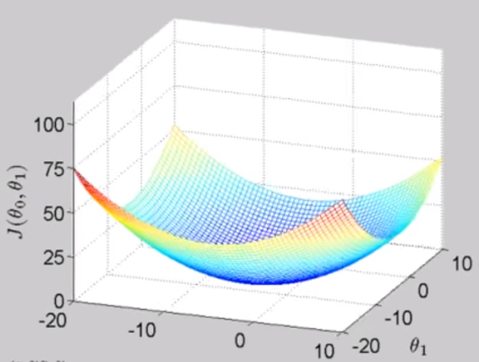

Figure 5: Cost function plot and contour

The above graphs have been plotted using arbitrary numbers for $θ_{1}$, $θ_{0}$ and the training set. As represented the left-hand side is a 3-dimensional plot of the cost function (convex function) while the right-hand side is its respective contour plot. Our goal is to minimize the ‘cost’ thus we need to find the values of $θ_{1}$ and $θ_{0}$ where the height (value of $J\left(θ_{0}{, θ}_{1}\right)$) is at its lowest. In this case there seems to be a local minima within the dark blue areas, the local minima has been marked with a black cross in the contour plot. So how do we write a program that will find the values of $θ_{1}$, $θ_{0}$ for us? This is where we use an algorithm called **gradient descent**.

In addition it turns out that all cost functions of linear regression is a convex function with only one local minima making it the global minima. Thus, gradient descent will always converge towards only one point which is the global minima.

3.3 Gradient Descent

Now imagine that you’re standing on the 3-dimensional plot in Figure 5. Your job is to walk to the local minima as fast as possible. The idea of gradient descent is that you will take a look at your surroundings and determine the direction that has the steepest slope down and taking a baby step towards that direction. This process repeated until you have reached the local minima. Note, that this method of gradient descent is often referred to as the “batch” gradient descent, as the algorithm has used all examples within the training set.

Now remember that in mathematics the gradient is considered to be the direction of fastest ascent, hence to descend in the fastest way possible we must move in the completely opposite direction. Therefore we must subtract the gradient of the cost function (J( $θ_{1}$ $θ_{0}$)) from the values of $θ_{1}$, $θ_{0}$. However notice that we cannot determine the derivative of J( $θ_{1}$ $θ_{0}$) in respects to both $θ_{1}$ and $θ_{0}$. Thus we must use partial differentiation and solve them separately as follows:

$${ { θ}_{1}=θ}_{1}-\frac{∂}{∂{ θ}_{1}}J\left({ θ}_{0}, θ_{1}\right)$$

$${{ θ}_{0}= θ}_{0}-\frac{∂}{∂{ θ}_{0}}J\left({ θ}_{0}, θ_{1}\right)$$

When applying this in code form, you must always update both $θ_{1}$ and $θ_{0}$ simultaneously. For instance, if the new value of ${ θ}_{1}$ is calculated first and updated. Then, the new value of ${ θ}_{1}$ will used throughout the calculation of ${ θ}_{0}$, while it should be calculated using the previous value, this is only relevant if you’re creating the function yourself from scratch.

Now remember that we take only small steps each calculation and that this must be done repetitively until we find or converge to the most optimal spot. Therefore, the new algorithm is as follows:

$${repeat until convergence: θ}_{k}= { θ}_{k}-α\frac{∂}{∂{ θ}_{k}}J({ θ}_{0}, θ_{1}) (for k=0 and k=1)$$

$α$ is referred to as the learning rate. The learning rate is always positive and this variable allows us to control how big of a step the algorithm will make during each calculation.

To get a better understanding of what gradient descent is actually doing let’s try and visualize it. Remember now that we are dealing with partial differentiation, therefore we can visualize the change of each ${ θ}_{j}$ through the conic section of the surface plot of J( $θ_{1}$ $θ_{0}$). The conic section of the cost function will look similar to the following whether you’re fixing $θ_{1}$ or $θ_{0}$:

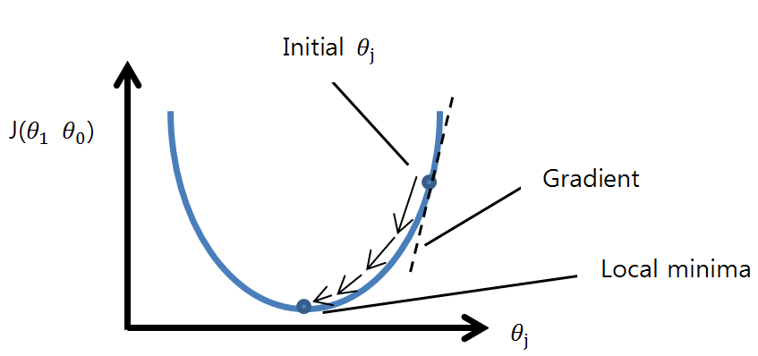

Figure 6: Cost function conic section breakdown

As you can see in figure 6, the conic section of the cost function is a parabola in 2-dimensions that we are all familiar with. This is what was illustrated when we plotted the cost function when fixating both ${ θ}_{0}$ and ${ θ}_{1}$. Furthermore, from this illustration we can observe three important behaviors.

Firstly, each step, as shown by the continuous black arrows, becomes gradually smaller. This is evident within the mathematics as $θ_{j}$ reaches the most optimal value, the gradient at each point is decreasing which has a direct correlation to the size of the step.

Secondly, notice that it doesn’t matter what the initial starting point of $θ_{j}$ is. When $θ_{j}$ is larger than the optimal value, the gradient is always positive. Thus multiplied with the learning rate which is also always positive, the number that is being subtracted from $θ_{j}$ will always be positive, hence ensuring that the future value of $θ_{j}$ will decrease and go towards the local minima. Meanwhile, if the value of $θ_{j}$ is smaller than the optimal value, the gradient is negative. Thus the value being subtracted from $θ_{j}$ will be negative; hence this will make sure that the next $θ_{j}$ value is larger than the current $θ_{j}$ value (as subtracting a negative number performs addition).

Thirdly, what happens if we were to start the algorithm at the most optimal value for $θ_{j}$? Well it’s actually quite simple. When analyzing our illustration in figure 6, if we start at the most optimal value then we can see that the gradient here is 0. Therefore mathematically we would get:

$${ { θ}_{j}=θ}_{j}-0$$

Thus, there would be no changes to the value of ${ θ}_{j}$. Normally at this point, the code will stop computing for ${ θ}_{j}$. Now you may be wandering, why don’t we just differentiate the equation of the parabola to directly find the value of ${ θ}_{j}$ when the gradient is 0? Well, we may discover later throughout this book that this is actually possibly a faster and simpler way to find the optimal value however, gradient descent is not only used in linear regression but applied in many different problems as well. An example would be using this algorithm to detect convergence on functions that have asymptotic behavior; this is why we mentioned that we repeat the calculation process until convergence not until we hit 0.

Now that we have a deeper understanding of what gradient descent does let’s actually mathematically expand and solve the gradient descent equation to its simplest form.

$${repeat until convergence: θ}_{k}= { θ}_{k}-α\frac{∂}{∂{ θ}_{k}}J({ θ}_{0}, θ_{1}) (for k=0 and k=1)$$

Subbing in $J({ θ}_{0}, θ_{1})$, we can represent this as:

$${ { θ}_{k}=θ}_{k}-\frac{∂}{∂{ θ}_{k}}\frac{1}{m}\sum_{i=1}^{m}{{\left(h_{θ}\left(x^{\left(i\right)}\right)-y^{\left(i\right)}\right)}^{2}} where k=0 and k=1$$

Now subbing in $h_{θ}\left(x^{\left(i\right)}\right)$:

$${ { θ}_{k}=θ}_{k}-\frac{∂}{∂{ θ}_{j}}\frac{1}{m} \sum_{i=1}^{m}{{\left({(θ}_{1}x^{(i)}+θ_{0})-y^{\left(i\right)}\right)}^{2}} where k=0 and k=1$$

When k = 0:

$${ { θ}_{0}=θ}_{0}-\frac{∂}{∂{ θ}_{0}}\frac{1}{m}\sum_{i=1}^{m}{{\left({(θ}_{1}x^{(i)}+θ_{0})-y^{\left(i\right)}\right)}^{2}}$$

By using chain rule we get:

$$Let u= {(θ}_{1}x^{\left(i\right)}+θ_{0})-y^{\left(i\right)}$$

$$∴{ { θ}_{0}=θ}_{0}- \frac{d}{du}\frac{1}{m}\sum_{i=1}^{m}{u^{2}}∙\frac{d}{dθ_{0}}u$$

$${ { θ}_{0}=θ}_{0}-\frac{1}{m}\sum_{i=1}^{m}{{\left({(θ}_{1}x^{\left(i\right)}+θ_{0})-y^{\left(i\right)}\right)}^{1}∙2∙\left(0+1-0\right)}$$

Therefore,

$${ { θ}_{0}=θ}_{0}-\frac{2}{m}\sum_{i=1}^{m}{{((θ}_{1}x^{\left(i\right)}+θ_{0})-y^{\left(i\right)})}$$

When k = 1: $${ { θ}_{1}=θ}_{1}-\frac{∂}{∂{ θ}_{1}}\frac{1}{m}\sum_{i=1}^{m}{{\left({(θ}_{1}x^{(i)}+θ_{0})-y^{\left(i\right)}\right)}^{2}}$$

Once again by using chain rule:

$$Let u= {(θ}_{1}x^{\left(i\right)}+θ_{0})-y^{\left(i\right)}$$

$$∴{ { θ}_{1}=θ}_{1}- \frac{d}{du}\frac{1}{m}\sum_{i=1}^{m}{u^{2}}∙\frac{d}{dθ_{1}}u$$

$${ { θ}_{1}=θ}_{1}-\frac{1}{m}\sum_{i=1}^{m}{{\left({(θ}_{1}x^{\left(i\right)}+θ_{0})-y^{\left(i\right)}\right)}^{1}∙2∙\left(x^{\left(i\right)}+0-0\right)}$$

Therefore, $${ { θ}_{1}=θ}_{1}-\frac{2}{m}\sum_{i=1}^{m}{{((θ}_{1}x^{\left(i\right)}+θ_{0})-y^{\left(i\right)})∙}x^{\left(i\right)}$$

Ultimately, the gradient descent algorithm in its simplest mathematical form is as follows:

$$repeat until convergence \{ { θ_{0}=θ}_{0}-\frac{2}{m}\sum_{i=1}^{m}{{((θ}_{1}x^{\left(i\right)}+θ_{0})-y^{\left(i\right)})},{ { θ}_{1}=θ}_{1}-\frac{2}{m}\sum_{i=1}^{m}{{((θ}_{1}x^{\left(i\right)}+θ_{0})-y^{\left(i\right)})∙}x^{\left(i\right)}\}$$

3.4 Tensorflow

In this book our coding will mostly revolve around using the tensorflow package. Tensorflow is a free and open-source library used by machine learning application developers all around the world. It’s mainly built to be used in python, however, there are experimental interfaces for Java, C++ and Go.

Tensorflow’s first version 1.0.0 was originally released during February 2017 which was developed by the google brain team to be used in deep/machine learning and neural network researches. It’s still being further developed and updated by google and the latest version of release in the time of writing this book which is April 2020 is 2.1.0. It’s important to know that version 2.1.0 of tensorflow is only supported for version of python 3.7 as of this moment.

You can refer to the installation guides within the appendix for an in-depth guide on how to install and use tensorflow and the packages within in it on windows.

Now there are huge differences between tensorflow version 1 and tensorflow version 2. We’ll get into the important differences later throughout the book. What’s important to understand here is how tensorflow is built to run.

Tensorflow’s general structure involves the computation of tensors. Tensors in physics and mathematics are just a multi-dimensional array or ‘grid’ of numbers. The first thing that may have popped up into your head may have been our beloved scalars, vectors and matrices from linear algebra. If you did well you’ve thought correctly. However, a common question that people ask is what is the difference between all the common terms in linear algebra and tensors?

Well, a simple and direct answer is that they’re interchangeable. It’s like asking yourself what’s the difference between a square and rectangle? Well we know that a square is just a special type of rectangle. In turns out that this is the same for our tensors.

We know that technically scalars are vectors or matrices with just one element and that vectors are special types of matrices where we are restricted to just 1 column, and, it turns out that all scalars, vectors and matrices are tensors. Thus, you can think of tensors as the level above matrices or a generalization of matrices where we can represent higher dimensions by stacking matrices on top of each other.

This is where understanding the ranks, shapes and types of tensors become very important.

**Rank**: The dimension of the tensor

|  |  |  |
| --- | --- | --- |
| Rank | Math entity | Python code |
| 0 | Scalar | s = 255 |
| 1 | Vector | v = [1, 2, 3, 4, 5, 6] |
| 2 | Matrix | m = [[1, 2, 3], [4, 5, 6], [7, 8, 9]] |
| 3 | 3-Tensor | 3_t = [[[1], [2]], [[3], [4]], [[5], [6]], [[7], [8]]] |
| n | n-Tensor | … |

**Shape:** The size of each dimension (Can be described as the dimension of dimensions)

|  |  |  |
| --- | --- | --- |
| Rank | Shape | Python Code |
| 0 | [] | s = 255 |
| 1 | [6] | v = [1, 2, 3, 4, 5, 6] |
| 2 | [3, 3] | m = [[1, 2, 3], [4, 5, 6], [7, 8, 9]] |
| 3 | [4, 2, 1] | 3_t = [[[1], [2]], [[3], [4]], [[5], [6]], [[7], [8]]] |
| n | [D0, D1, …, D­n-1] | … |

**Types:**

|  |  |  |
| --- | --- | --- |
| Data Type | Python type | Description |
| DT_FLOAT | tf.float32 | 32-bit floating number |
| DT_DOUBLE | tf.float64 | 64-bit floating number (commonly just called double) |
| DT_INT8 | tf.int8 | 6-bit integer |
| DT_INT16 | tf.int16 | 16-bit integer |
| … | … | … |

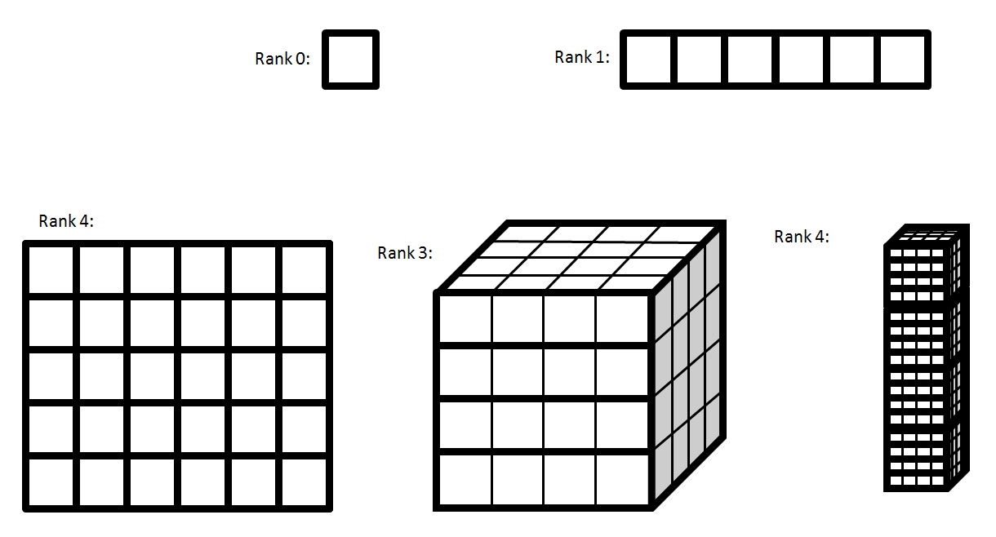You can view tensors of different ranks by the following illustration

Many people seem to forget or not understand the difference between ranks, shapes as it can be very confusing. So make sure that you’re on top of not only knowing the difference between them but also being able to define their values given a data set as this becomes very important when coding our machine learning models.

Tensors were actually mainly used in physics to calculate things like elasticity and many more. So why use tensors in building machine learning models? Well, it’s simply the fact that it’s an amazing way to represent data in extremely high dimensions. As we know things in the real world tend to change due to lots of variables and to represent this in coding format, tensors seem are best way to go about it.

3.5 Solving Univariate Linear Regression Problem with Code

Now that we understand the mathematical background of linear regression let’s actually apply this in code form. From here on it is expected that you have some background knowledge in python coding. In the following we will try to construct our code step by step.

Step 1: Here are all the necessary imports for this exercise:

|  |
| --- |
|  |
|  | import tensorflow as tf  from keras.models import Sequential |
|  | from keras.layers import Dense |
|  | from keras.optimizers import SGD |
|  | import matplotlib.pyplot as plt |

Step 2: Firstly we need to make a training set; we will be using the example in Table 1, Chapter 2. This is simply done by inserting our data in to lists:

|  |
| --- |
|  |
|  | popularity = [3, 8.9, 12, 17, 20, 25, 31.6, 51.2] |
|  | price = [500, 900, 1050, 1300, 1250, 1400, 1500, 1550] |

Step 3: You can also plot the training set on a graph by using the matplotlib library.

|  |
| --- |
|  |
|  | plt.scatter(popularity, price, label="Training Set") |
|  | plt.xlabel("Populartiy of ML101") |
|  | plt.ylabel("Priced of ML101") |
|  | plt.show() |

Step 4: Now we need to make a keras model. Keras models are a high-level framework for neural networks that can hold multiple layers. For the moment you don’t need to understand neural networks for this activity. All you’ll need to know is that in this exercise one layer is sufficient enough to successfully test gradient descent on our training set. Additionally, these models will produce the hypothesis by learning with the training set provided.

We will first create a keras model:

|  |
| --- |
|  |
|  | model = Sequential() |

Step 5: Then we will add our layer to our keras model. We will use a class called Dense which is the most basic type of layer. Here the first argument is the number of outputs thus we will set it to 1 and the second argument ‘input_dim’ which stands for input dimensions will be set to 1 as we only have one feature (popularity):

|  |
| --- |
|  |
|  | model.add(Dense(1, input_dim=1)) |

Step 6: Now we need to compile the model before we can make let it start training/learning. We will need to pass an optimizer in our argument, thus we will create a stochastic gradient descent (SGD) optimizer and tell it to optimize using the cost function or mean squared error (mse):

Notice that we have an argument when creating our SGD. This value is the learning rate which we will touch more upon very soon.

Step 7: Now let’s make the model learn. Here we will use the fit() method within the Model class. To use this method we will need to pass the training set in the order of input, output then also specify the number of iterations (epochs) that we want the algorithm to forego. We will also plot the loss to get a clearer idea of what’s happening to the cost while the algorithm runs.

**[Additional information]** Reading the learning output

When using the fit() method, it returns an instance of the History class. This history object holds data that was produced during each iteration. By accessing History.history which is a dictionary, we can specify the key in this case ‘loss’ and access the values of the cost function during each iteration.

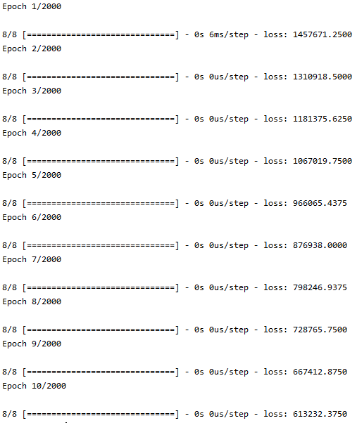

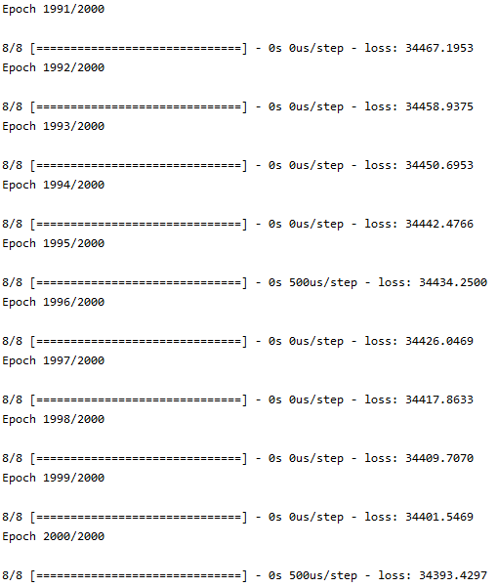

Figure 7: Univariate linear regression code output

**[Additional information]** Reading the learning output

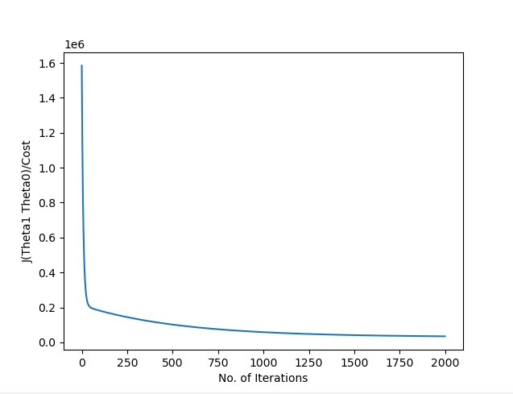Here ‘loss’ is the value of our cost function or mean squared error value. Remember that this is because we set the loss to be ‘mse’ when compiling our keras model. Also epochs just means one iteration, more specifically means one loop around the training set.

Figure 8: Univariate linear regression loss/cost plot

We can clearly see from both figure 7 and figure 8 that the gradient descent algorithm is working successfully as the cost gradually decreasing. Reminder that the higher amount of iterations the more accurate gradient descent will be thus you can experiment changing the values of ‘epoch’ when calling the fit() method.

Step 8: Now let’s predict what the price of ML101 would be when the population reaches 10 (1000 people). This will be done by using the predict() method and the argument will be a list of inputs that we want to make our predictions for:

The output should look similar as the following:



As shown above the prediction ($883.2894) is quite different compared to our prediction of ($960) in chapter 2. This will highly likely just mean that either we have predicted wrong or the number of iterations is too low and we need to let our keras model learn more (epochs). For example:

And now you should observe that after predicting with the fit() method once again, your output should look similar as the following:



You can now see that the prediction is much better after increasing the amount of iterations.

The following is the full code from step 1 to step 7 for solving our univariate regression problem:



In most activities we will also show you the code for when coding in tensorflow version 1.

**[Additional Information]**Tensorflow v1 vs Tensorflow v2

Overall, both versions obviously have the same idea and goal, which is to be a package that users can use to create machine learning/ neural network models. However, they have some drastic differences between them.

Firstly, the main difference is the addition of eager execution. In tensorflow v1, programmers would need to write code that would fill this thing called ‘computational graph’. As we mentioned above this graph to simply put is just a holder for variables and computations within your code. To actually use this graph which is technically running your code, you would need to create a session. During runtime, a session pretty much allows you to access all parts of the graph to actually execute the code. You will see this in more details within the code provided later.

Additionally, in our example above which is using tensorflow v2, the Keras package has been added/in-built into tensorflow. Before tensorflow v2 came out, tensorflow v1 users would have to either get Keras manually or possibly look for other packages that helped make neural network models, now this isn’t necessarily a big setback. H

However, to make frameworks that would act like Keras models purely in Tensorflow, you’d need to write a much longer code. But, we shouldn’t necessarily view this as a negative.

Although our codes in tensorflow v1 can get a little messy and longer, the way that we have to write our code in tensorflow v1 actually helps beginners to fully understand how the mathematical background of these machine learning algorithms are applied in our coding. You’ll be able to see this when analyzing the code.

Here is the tensorflow v1 of our univariate linear regression code:

As you can see it’s much longer than our code when using tensorflow v2. In the above code you will notice that we manually have to create the hypothesis and cost function meanwhile in version 2 this is done in just 1 line by using keras. Similarly, this is also the case for fitting our line, where we have to specifically create the iterating algorithm by using a while loop. You’ll see later for other machine learning models we must do this as well when using version 1.

**Just a reminder that you will not need to turn off eager execution and not have to use the keywords .compat.v1 when using tensorflow v1.**

Here are the outputs for the above code using tensorflow v1:

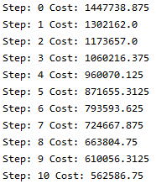

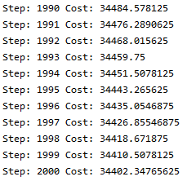

Figure 8: Univariate linear regression output (Tf.v1)

You can see the cost difference between our two codes are very small.

3.6 Learning Rate Limitation

There is actually something very important that we haven’t talked about yet. As we mentioned above, the learning rate will decide how big of a ‘step’ the gradient descent algorithm takes when calculating each iteration. But, what is really happening when changing the value of our learning rate?

Let’s try changing our learning rate value to 0.0001 as the following:

After running the modified code the output look similar to the following:

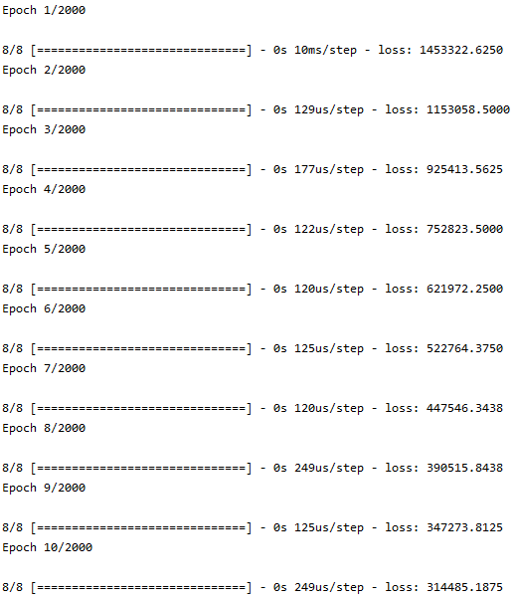

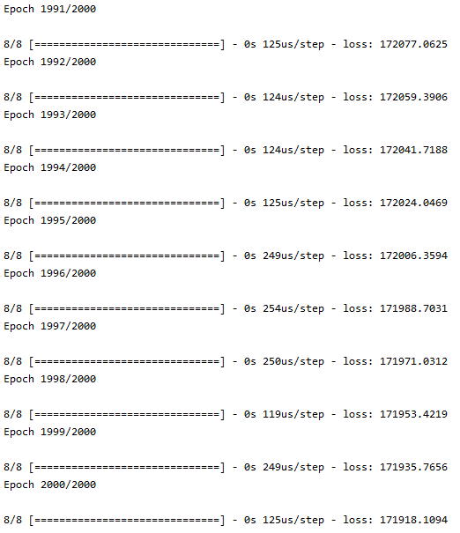

Figure 9: Low learning rate output

It’s evident within figure 9 that the loss values are much larger than the values within figure 7 meaning that the model is learning/minimizing at a much slower rate. You should be able to understand this intuitively as, a slower learning rate just means that the algorithm is taking smaller ‘steps’ each calculation, thus increasing the overall time to minimize our cost function.

Now you should be expecting that this algorithm will minimize faster if we increase the learning rate value. Let’s try this out to check if we’re correct.

Your output should now look something like this:

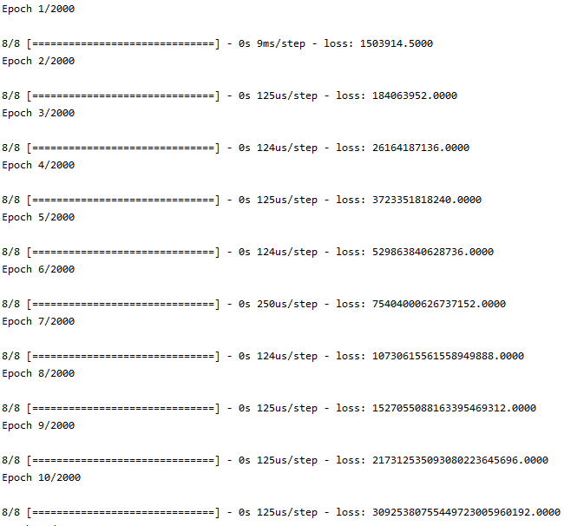

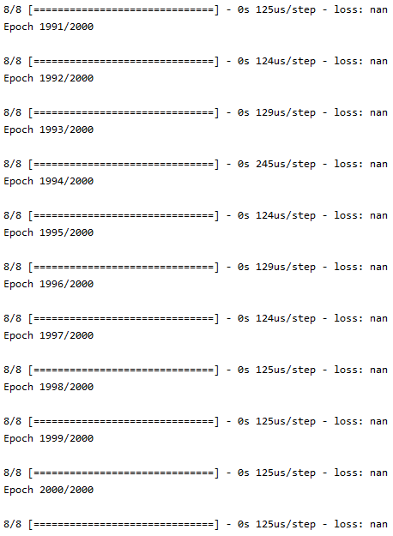

Figure 10: High learning rate output

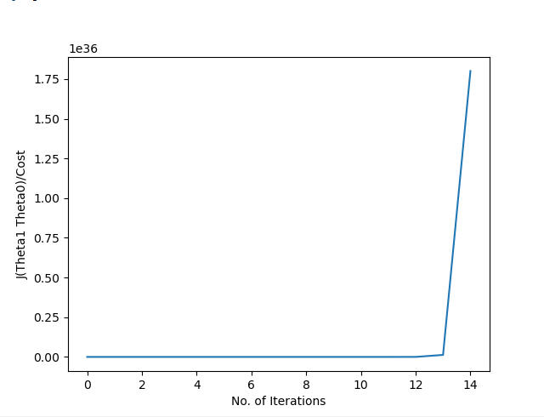This time we will also plot the cost to iterations graph:

Figure 11: High learning rate plot

From analyzing the output illustrated in figure 10 and figure 11, you should immediately realize that the gradient descent algorithm is behaving strangely. We can see that the loss/cost is increasing whereas for the algorithm to create a successful hypothesis we know that it should be decreasing. In fact it’s increasing exponentially fast that by the end the loss/cost has been represented as NaN (Not a number).

This is a phenomenon that actually happens when the learning rate is too big. We won’t mathematically prove this here, but know that when the ‘steps’ are too big in gradient descent; you will find that the algorithm will actually start diverging, similarly to the diagram below in figure 12.

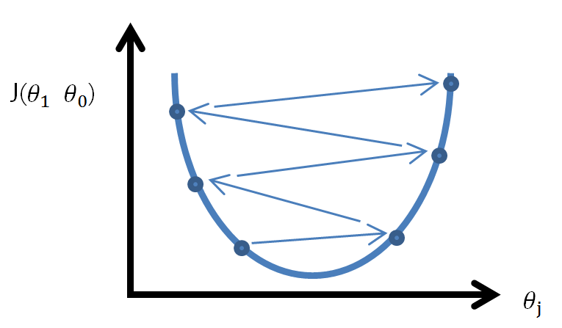

Figure 12: Gradient Descent Divergence

When something like this occurs you should always first consider lowering the value of your learning rate. You may now be asking how do we choose an appropriate learning rate value?

The easiest way is to just randomly try values out. Starting from a value that actually diverges is great as you can slowly decrease the learning rate until it reaches the threshold of numbers that will let the gradient descent algorithm converge. Where or what this value of threshold will be is completely dependent on your training set, each linear regression problem that you encounter will most likely have a different value for this threshold. Thus, to make our algorithm the most optimal, we want our learning rate to be as large as possible, but, at the same time being below the threshold of values that will make SGD diverge.

3.6 Optimizing Gradient Descent

In Chapter 3.5 above we briefly discovered, changing the learning rate can affect the speed/optimization of our gradient descent algorithm itself. Now let’s take a look at a couple of another ways to do this.

From here on the inputs in our training set (population of ML101) will be referred to as features. In Chapter 4 we will discover how to deal with training sets that deals with multiple features.

Gradient descent (GD) vs Stochastic gradient descent (SGD):

Most of you reading this have probably not realized, but in our code we have actually already applied a slightly different algorithm to the gradient descent that we have mathematically studied. Note that neural networks can learn from multiple training sets rather than just one.

The gradient descent that we have studied also known as the “batch” gradient descent uses all data within all the training sets provided for each calculation. However, stochastic gradient descent **only one or a subset** of the training sets. Hence, when the amount of training sets are large, SGD will optimize faster compared to GD. However, this means that SGD will be less accurate compared to GD as it only uses a subset of data given.

Normalization of data:

Another way to speed up our cost function optimization is to mean normalize our training set.

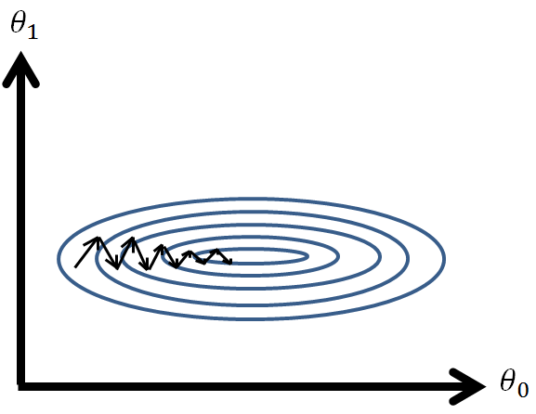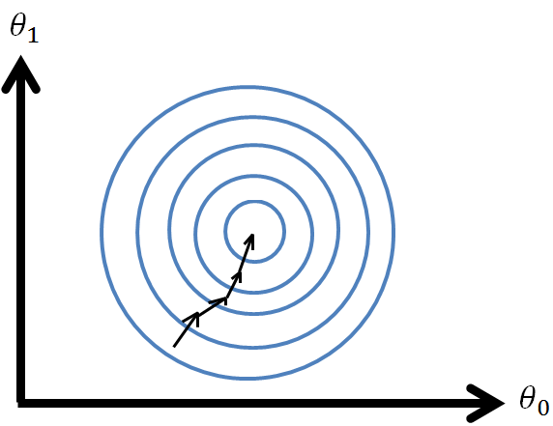

Figure 13: High variance vs Same variance

When the features within our training set have high differences in their variance, the contour of our cost function will become very ‘squished’, this can be observed in the left hand-side diagram in figure 13.

When our cost function behaves like this our gradient descent (GD) algorithm can have a hard to optimizing this as it will take a ‘zig-zag’ path as shown above, making the algorithm take a greater amount of ‘steps’ which has a direct relationship to the time it takes to optimize. Meanwhile, when the variances of our features are same or similar, than our algorithm will have no trouble going straight to the optima.

Note that this doesn’t apply when dealing with univariate linear regression. Thus, we will see how to mean normalize our training sets after learning multivariate linear regression in the next chapter and also discover other ways to optimize GD that applies to linear regression with multiple variables.

3.7 Summary and Exercises

In this chapter we studied thoroughly the process of machine learning algorithms in general and what linear regression is. Specifically we looked at the mathematical fundamentals behind univariate linear regression and how to apply it using tensorflow.

The general idea is that by feeding a data set into our machine learning model, the algorithm will ‘learn’ and ultimately produce the most optimal hypothesis which in this case is a linear function, since we’re dealing with linear regression. We can then feed new values into this hypothesis to get a prediction for the future.

To produce the correct or the most optimal hypothesis the machine learning model uses an algorithm called gradient descent on the cost function. By doing an iterative approach like this we can find the best values for both the gradient and y-intercept of the hypothesis function.

Then, the application of linear regression was shown by coding in python using tensorflow and keras packages and also discovered that there are different types of gradient descent algorithms such as the stochastic gradient descent.

We also learnt some base structure of tensorflow, differences between tensorflow version 1 and 2, and also discovered the limitations that you may run in relations to the learning rate within the gradient descent algorithm.

The optimization of gradient descent was briefly mentioned towards the end of the chapter, illustrating some of the problems that may occur when using gradient descent. In the next chapter we will show how these can be avoided and also dive a little deeper into more complex linear regression problems.

**Questions:**

1. What is linear regression?
2. What is the technical term for the very first data that is provided to a machine learning model
3. What is a univariate linear regression?
4. Explain what the cost function calculates
5. Explain how gradient descent works
6. Explain the relationship between the cost function and gradient descent in machine learning
7. Explain what the learning rate is in gradient descent and the effect it has on gradient descent when changing the value of it.
8. Explain the limitations on the learning rate
9. Can our training set actually affect the performance of the gradient descent algorithm if so why?
10. What are tensors?
11. Explain what ranks, shapes and types are in tensorflow and state two different types
12. For the following tensors in python, state their ranks, shapes and possible data type:

* X = [538]
* X = [16, 8, 7, 23, 24.5]
* X = [[[1, 2, 3], [2, 3, 4]], [[1, 3, 2], [1, 6, 7]]]

**Answers:**

1. Linear regression is just an approach to solving regression problem linearly, by fitting linear lines or hyper planes to the data. (Hyper planes will be covered in the next chapter)
2. Training set
3. Univariate linear regression is just linear regression where the outputs only depend on just one variable. Hence, the name univariate where uni means one and variate means variable.
4. The cost functions calculate the summation of distances from all outputs (y) within training to the hypothesis function. It basically measures the error of the hypothesis. Additionally, the cost function is also commonly referred to as the mean square error function.
5. Gradient descent is an iterative approach to find the local minima of functions by repetitively subtracting the gradient from the current position until convergence or when the gradient hits 0. We know that this will work since the gradient is the fastest direction of ascent.
6. Since a machine learning algorithm’s job is to fit a line that is the closest to all training set outputs (y) which also means that the cost/ mean square error function is the smallest value possible, we can use gradient descent to find the spot where the value of the cost function is at its lowest. Thus this point will give us the values for the thetas/parameters for our hypothesis.
7. The learning rate in gradient descent represents the ‘steps’ taken in each iteration of the gradient descent algorithm.

By using the learning rate we can technically ‘scale’ the gradient that is being subtracted to as big or as small as we want it to be. Thus increasing or decreasing the speed of gradient descent at the cost of accuracy

**Reminder:** Note that the accuracy isn’t really effect so much in gradient descent since there is only 1 local/global minima. However on surfaces with lots of minima’s’ the accuracy will definitely be effect by the change of the learning rate value

1. When values of the learning rate are too small, it can take the gradient descent too long to find a decent/optimal function making the iterative process very expensive. Meanwhile if the learning rate is too large, gradient descent can actually diverge.
2. Yes, training sets can actually affect gradient descent’s performances. When variances between the features are too large (meaning that the values of features are not within similar ranges) then the cost function can look very squished or elongated. This will make gradient descent take much longer to get to the most optimal spot.
3. Tensors are a generalization of matrices. It’s a mathematical object that can describe vectors and matrices in dimensions that are higher than 3. Tensors are interchangeable with vectors and matrices.
4. Ranks describe the dimension of the tensor itself. Meanwhile the shapes determine the size of each dimension/elements. Shapes are often referred to as the dimension of dimensions. The types are specifically referring to data types such as 8-bit integers and 32-bit floats.
5. i) Rank : 1

Shape : [1]

Type : 8-bit integer

ii) Rank : 1

Shape : [5]

Type : 32-bit float

iii) Rank : 3

Shape : [2, 2, 3]

Type : 8-bit integer

1. Multivariate Linear Regression

4.1 Introduction

In this chapter we will learn how to solve linear regression problems with multiple variables also known as multivariate linear regression. From here on you should be familiar with simple linear algebra, solving univariate linear regression problems using gradient descent and also understanding the fundamentals of gradient descent.

But now, let’s take a step deeper. We all know that applications within the real world are very complex; things don’t depend on the change of just one factor. Take economy for instance, the economy will fluctuate due to the change in natural resources, population, supply and demand, and many more. So, how do we solve multivariate linear regression problems?

This is where some simple linear algebra can be extremely helpful. Let’s discover a couple of new notations:

4.2 Changes From Linear to Multivariate Linear Regression

Let’s assume that there exist a post office that sells postal boxes, and these boxes depend on the dimensions of the box. The table (training set) below is their box price rates.

|  |  |  |  |
| --- | --- | --- | --- |
| Width (mm)  (x1) | Length (mm)  (x2) | Height (mm)  (x3) | Price ($)  (y) |
| 400 | 180 | 200 | 4.20 |
| 430 | 140 | 305 | 4.85 |
| 405 | 255 | 300 | 6 |
| 180 | 180 | 180 | 3.50 |
| 220 | 100 | 160 | 2.70 |
| 405 | 255 | 300 | 6.50 |
| 500 | 350 | 440 | 11 |
| 1500 | 900 | 200 | 20.50 |
| 1500 | 900 | 900 | 39.80 |
| 1000 | 1000 | 1000 | 35.30 |

Table 4: Price of Post boxes

Notations:

n = number of features (n = 3 in Table 4).

x(k)(i)= value of feature k in the ith training example.

Note that the notations that were used within chapter 3 still applies with the exception of notations that have been modified.

Notice that in most multivariate linear regression training sets are not within the 2 and 3-dimensions models that we are familiar with (Obviously we cannot be in 2-dimensions but we can be in 3-dimensions). Thus, this makes it extremely hard not only to analyze the sets but to also predict the outcomes of inputs that aren’t within the training set. Hence we will need to just take a look at how the algorithms are changed and applied mathematically. After studying the mathematical background of our new algorithm we’ll once again apply this in our code using tensorflow.

4.3 Mathematical Changes from Linear to Multivariate Linear Regression

Now that we’re dealing with multiple variables/features our hypothesis will need to change compared to the one we had in our univariate linear regression problem.

We will now generalize the hypothesis for linear regression:

$$h_{θ}\left(x\right)=θ_{0}+θ_{1}x_{1}+θ_{2}x_{2}+…+θ_{k}x_{k}$$

$$where k∈ N$$

But let’s modify the equation to be:

$$h_{θ}\left(x\right)=θ_{0}x_{0}+θ_{1}x_{1}+θ_{2}x_{2}+…+θ_{k}x_{k}$$

$$where x_{0}=1 and k∈ N$$

By explicitly adding x0 to our equation we can now represent the set of xk and $θ_{k}$ as:

$$X= \left[\begin{aligned}x_{0} \\ x_{1} \\ … \\ x_{k}\end{aligned}\right] and θ= \left[\begin{aligned}θ_{0} \\ θ_{1} \\ … \\ θ_{k}\end{aligned}\right]$$

$$where x_{0}=1 and k∈ N$$

When we transpose $θ$, $θ^{T}$ becomes the same as the following:

$$θ^{T}=[θ_{0} θ_{1}… θ_{k}]$$

$$where k∈ N$$

And now when we matrix multiply $θ^{T}$ and X together we get:

$$θ^{T}×X= \left[θ_{0} θ_{1}… θ_{n}\right]×\left[\begin{aligned}x_{0} \\ x_{1} \\ … \\ x_{k}\end{aligned}\right]$$

$$=[θ_{0}x_{0}+θ_{1}x_{1}+θ_{2}x_{2}+…+θ_{k}x_{k}]$$

$$where x_{0}=1 and k∈ N$$

**[Additional information]** Matrix multiplication

Remember that matrix multiplication is not commutative meaning that:

$$θ^{T}×X ≠X ×θ^{T}$$

In this case since:

$$X=\left(n+1\right) ×1 matrix$$

$${and θ}^{T}=1 ×\left(n+1\right) matrix$$

By performing:

$$H=X ×θ^{T}$$

$$we would get a matrix H=\left(n+1\right) ×\left(n+1\right) matrix$$

Therefore, we must multiply in the order of $θ^{T}$ then X.

Now, notice what we get from our matrix multiplication is just our new generalized hypothesis that we showed above. Hence we can simply represent our new hypothesis as:

$$h_{θ}\left(x\right)=θ^{T}X$$

Now let’s see how this will affect our gradient descent algorithm.

Here is the previous algorithm:

$${ { θ}_{1}=θ}_{1}-\frac{∂}{∂{ θ}_{1}}J\left({ θ}_{0}, θ_{1}\right)$$

$${{ θ}_{0}= θ}_{0}-\frac{∂}{∂{ θ}_{0}}J\left({ θ}_{0}, θ_{1}\right)$$

Expanding this we get:

$${ θ_{0}=θ}_{0}-\frac{2}{m}\sum_{i=1}^{m}{{((θ}_{1}x^{\left(i\right)}+θ_{0})-y^{\left(i\right)})}$$

$${ { θ}_{1}=θ}_{1}-\frac{2}{m}\sum_{i=1}^{m}{{((θ}_{1}x^{\left(i\right)}+θ_{0})-y^{\left(i\right)})∙}x^{\left(i\right)}\}$$

Now we can generalize this for all ${ θ}_{k} and x_{k}$:

$${{ θ}_{k}= θ}_{k}-\frac{∂}{∂{ θ}_{k}}J\left(θ\right)$$

$$where k∈ N$$

And when expanding we just need to change

$$x^{\left(i\right)}→ {x_{k}}^{\left(i\right)}$$

Thus:

$${{ θ}_{k}= θ}_{k}-\frac{2}{m}\sum_{i=1}^{m}{{((θ}_{1}x^{\left(i\right)}+θ_{0})-y^{\left(i\right)})∙}{x_{k}}^{\left(i\right)}$$

$$where k∈ N$$

And our final algorithm is:

$$repeat until convergence \{ {{ θ}_{k}= θ}_{k}-\frac{2}{m}\sum_{i=1}^{m}{{((θ}_{1}x^{\left(i\right)}+θ_{0})-y^{\left(i\right)})∙}{x_{k}}^{\left(i\right)}\}$$

$$where k∈ N$$

Now it’s interesting to see that when using vectors and matrices to represent out set of X and $θ,$ as we mentioned briefly in chapter 3, you can actually calculate the most optimal values for $θ$, by using the normal equation.

The normal equation is as follows:

$$θ={\left(X^{T}X\right)}^{-1}X^{T}y$$

$$Where X is the matrix of the all features and y is the vector of outputs$$

The intuition is that when we’re looking at a simple quadratic equation as such:

$$y=ax^{2}+bx+c$$

We can optimize this equation by:

$$\frac{d}{dx} y= \frac{d}{dx}ax^{2}+bx+c=0$$

And by doing this we can find the local optimas analytically meaning that we find the values within just one go.

Now something to note is that, if your linear algebra background is solid, you’ll know that not all matrices have inverses. Mathematically speaking, this means that your data is not linearly independent. This means that one or more vectors within your matrices or in this case which are features will be a scalar product of another. Meaning that

$$For a certain X_{i}, where i∈N$$

$$there exists a certain X_{j}, where j ∈N$$

$$such that X_{i}= α X_{j}$$

$$where α ≠0 \left(Note that here α is not the learning rate it is just a scalar number\right)$$

Let’s take our post box data for example. At the moment our data is made up of the width, length and height of the box where their units are in millimeters and, we all know that they are not directly related to each other. However if we were to insert another feature called something like widthcm where you have the exact same data as width however converted to centimeters rather than millimeters then our matrix X will be linearly dependent as width = 0.1widthcm and our X matrix would not have an inverse.

Ultimately, using the normal equation can definitely be much faster than gradient descent, however that will depend the amount of features we have. When having hundreds of thousands if not millions of features, computing matrices of such dimensions is very costly even for computers today. Thus choosing when to use the normal equation is very important.

4.4 Solving Multivariate Linear Regression Problem with Code

In our previous example in chapter 3 for our univariate linear regression example we used basic List() that was built into python. However, this time we will take a look at the numpy package and use it to make our training sets.

**[Additional information]** Numpy Package

Numpy is a python package that includes useful classes for multi-dimensional arrays and matrices. This is a very crucial and important package for all AI programmers that are using tensorflow to code their neural networks so it’s good to get use to using it now than later. This package also includes a wide variety of complex mathematical functions that can operate on any of the arrays and matrices produced by numpy.

We can create simple one-dimensional arrays using numpy like the following:

The first argument is an “array_like” object according to the numpy documents. Strings are also a possible “array_like” object that you can pass through. For our examples we’ll be using mostly lists. The second argument ‘dtype’ which stands for data-type has be set to float, however this is optional as it is set to the minimum data type needed for the list that we pass through by default.

Let’s now try and construct our code step by step again:

Step 1: Here are all the imports necessary for the following activity

Step 2: We now need to create our training sets. Note that now we’re dealing with multivariate linear regression, so we need to be very careful how we create our training set input.

Remember that we are going to use matrices to represent our features. We need to make the input of our training set to be in the format of the following:

$$\left[\begin{matrix}x_{11} & ⋯ & x_{1j} \\ ⋮ & ⋱ & ⋮ \\ x_{i1} & ⋯ & x_{ij}\end{matrix}\right]$$

$$where j≤n and i, j, n ϵ Z^{+}$$

In the above matrix:

$$i is the i^{th} element and j is the j^{th} feature$$

So how do we create this using numpy?

Well it’s quite simple. When looking at the additional information section about numpy, we showed you how to create the input for our training sets when we are dealing with one variable. So, the way we need to think about it now is to think that there is a big outer list and the elements within that list is a smaller list including each ith row of data. Something like the following:

$$x_{train}=\left[\left[1, 2,3\right],\left[4,5,6\right],…,\left[…\right]\right]$$

which is basically a matrix like the following:

$$x_{train}=[\left[1,2,3\right],$$

$$\left[4,5,6\right],$$

$$\left[7,8,9\right]]$$

Thus here’s how we need to create our numpy array for our 3 features:

And then we can create our output using numpy as usual:

Step 3: Now let’s once again create our keras model:

Step 4: Then we will add our layer. We’ll once again use the Dense() layer however, remember that the arguments are the dimensions of the output and input in that respective order. Furthermore, the input dimension is now going to be 3 as we have 3 features and the dimension of the output hasn’t changed. Thus our code will look like the following:

Step 5: Now we’ll now create our optimizer using the SGD() once again.

Step 6: We’ll now compile the model and also use fit() to make our model learn:

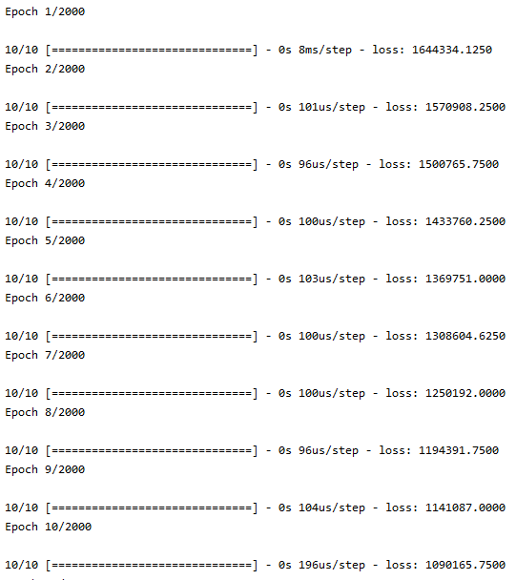By running what we have at the moment you should an output similar to the following (It won’t necessarily be the same however as long as the cost function is decreasing and converging then it means that SGD is doing the correct job):

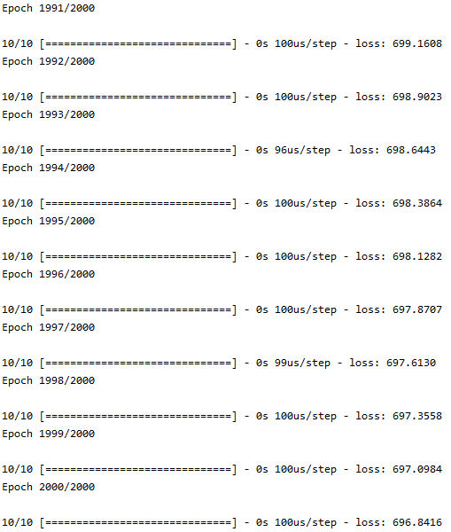

Figure 15: Price of Post boxes

Step 7: Now let’s go ahead and **plot the cost function** and do a **prediction** for the cost of a post box that has the dimensions of 78 x 80 x 75. Once again, never forget that your input dimensions must be the same as the original training sets. It’s a common mistake for beginners when working with higher dimension data sets. Thus, we will be using the array() method in numpy to create our prediction data when passing it to the argument in the predict() method.

Your code should look like the following:

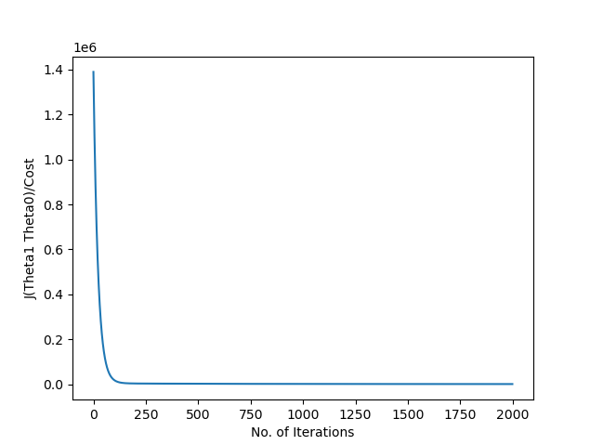The output should now look similar to the following:

Figure 16: Multivariate linear regression cost function



Figure 17: Multivariate linear regression prediction

You can probably immediately notice that although the gradient descent algorithm worked as we wanted, our prediction is quite bad. As we were trying to predict the price of a box with the dimensions 73 x 80 x 75 where the values of all features is smaller than any training example within our training set, we would expect it to predict something under $2.70.

There are some issues with this model. Firstly the learning rate has to be extremely low, as we learned above this just means that we will converge to the optima much slower. Thus if we’ve done everything correctly then, that will most likely mean we need to change our model or just do more iterations. We can change our models by either adding more layers or completely using a different algorithm. Now because we haven’t really covered neural networks or different optimization algorithms we might need some other strategies.

Here is the full code that was written from step 1 to step 7:



And here is the code and output for tensorflow v1:



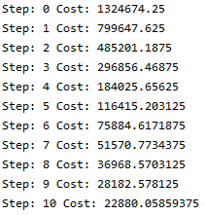

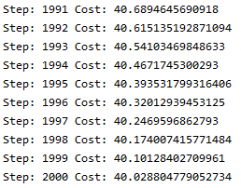

There is actually one very important step that we haven’t really applied just yet and that is **data preprocessing.** We’ve touched on upon a certain stage of data preprocessing called feature scaling a little above in chapter 3 but now let’s really analyze how we can implement it.

**[Additional Information]** Data preprocessing

Data preprocessing is actually a process that involves many stages. It starts from importing and reading data from certain files such as a csv files then it can check for missing values and whether we have any categorical features or not. After that it will standardize/normalize data and split the data into the correct inputs and outputs necessary for creating our training set. There are much useful functionality built into packages such as keras, numpy and Pandas that you can use to easily access data files. Note, what we have listed isn’t actually the complete process of data preprocessing but it’s a pretty good generalization that should be able to give you an understanding of it.

For many, in fact most machine learning algorithms, data preprocessing is a must. We weren’t actually able to cover much of this process because we were manually inputting values into our code rather than having an external file with all of our data. So let’s see how we can read and load data from a file.

For this example, we will be using a csv file and functions within the numpy package to load our data. Csv files, which stands for comma separated values file literally is what the name says it is. It’s a text file that has data or values within the data that have been separated with commas.

Creating csv files:

Step 1: Open up a new text document by right-clicking desktop -> New -> text document. Here you need to type all values; we’ll see how the values should be formatted very soon.

Step 2: You will now need to save as (Not just save!) and rename the file extension as csv by deleting where it says .txt and replacing it with .csv.

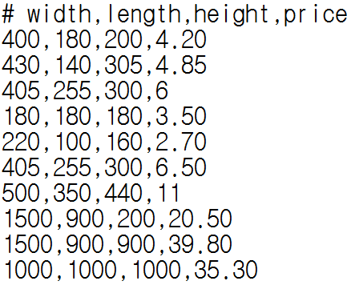The contents of your csv file should look like the following, just a reminder that we have used the example in table 4 above:

Reading File:

Step 1:

When using the numpy.loadtxt() function you will need to specify the full file name with the file extension, the delimiter, possibly comment and the dtype or data type.

Here the delimiter just specifies the string used to separate values within our file and since we are using a csv file, we need to specify a ‘,’.

For the data type since we have floating point numbers we will specify np.float32 (32-bit float number). If you are comfortable with data types and you know that you can use smaller data types than floats then you can do so.

There is also an argument called comment, this argument tells the function where your values start at. It is set to the hash-tag symbol by default when not specified thus the reason why our csv file started with a ‘#’. This argument is extremely useful when you want to read multiple data in within just 1 csv file.

Now at this point you can check what your read_data variable holds



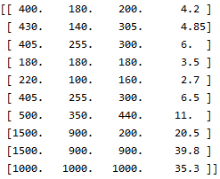

Step 2: We can now use the in-built python slicing functionality to easily separate our x and y variables.

For those of you not so familiar with this functionality here’s how slicing works:

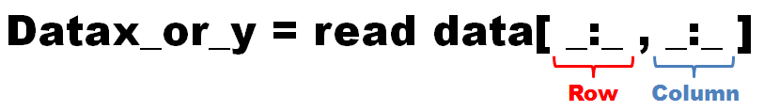

Thus to split up our train_x and train_y our code will look something like the following:

**[Additional information]** Slicing techniques

1. Number in-front of the colon is the starting point and the number after is the ending point, but **not** including it.
2. To get all rows/columns you can leave the numbers blank as shown above
3. Do not need to use colon if only looking for one row/column
4. Negative indexing is allowed in python, where -1 is equivalent to the last index and so on

We can now print to check that our training set is in the correct format that we want.

And as you can see below in the output, we have exactly what we need.

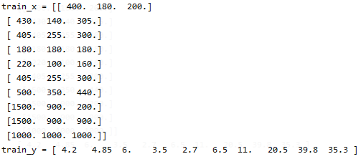

For tensorflow v1 users we’re going need to split the data in a slightly different way as we need to separately split up each feature. For this your code should look like the following:

You should now be able to modify the original code by reading in data from files instead of having to write the data manually into our code.

Now after loading in our data we must scale our features. As we mentioned in Chapter 3, it can take our algorithm a much longer time when the variances between our features are large as the contour of our cost function will turn out to be extremely elongated. For example if feature 1 was to take the values of the range of 1~10 while the values of feature 2 are between 1000~20000 than this kind of behavior can be observed. To fix this we can either standardize or normalize our data set.

To simply put, all standardizing/normalizing the training set does, is scale down our features (feature scaling) to be within the same range.

Let’s now check out how these are applied mathematically:

**Normalization:**

$$X_{normalize}=\frac{X-X_{min}}{{Range}_{X}}$$

$$=\frac{X-X_{min}}{X_{max}-X_{min}}$$

$$where X is set of features$$

**Standardization:**

$$X_{standardize}=\frac{X-μ}{σ}$$

$$where X is the set of features, μ and σ is the mean and standard deviation of X respectively$$

It’s important to remember that these are two different techniques. In very special cases they can be interchangeable however; usually they produce two different results whether it’s noticeable or not numerically. Normalization scales the features down to be within the range of 0 and 1; meanwhile standardization scales the features down to be within the range of 0 and a standard deviation of 1. For the moment we won’t get into actually understanding when to use which method, but, it is recommended to use standardization over normalization as much as possible.

Now don’t be fooled, this technique of optimizing gradient descent doesn’t necessarily help us in all areas of machine learning. Although it will most likely improve the speed by tremendous amount, it can actually alter and decrease the accuracy of predictions.

When using **normalization**, the ‘noise’ of our data set can be amplified. ‘Noise’ here is referred to be the distortion of data. When plotting your normalized data you will see high distortions where your data will have a repetition of zig-zag behavior or high-fluctuations, thus making your data look like an unpredictable training set. To understand why this is, think of it like this; imagine you have plotted a data set that is has extreme fluctuations within each point. Now imagine that you’ve zoomed out of the graph quite far away. At this point what you should see is a fairly straight line that a machine would have a much easier time accurately learning. Hence, this is why normalization can be at times not the best option.

**Standardization** on the other hand has its own limitations. Most of you should know that mean and standard deviation are hugely affected by anomalies. Thus, when standardizing data that have lots of anomalies, you can lose very important information within data. For example, things that was concretely extinguishable such as day vs night or cold vs hot can actually be lost. Not only that, in normalization there is no possibility of negative numbers as we are subtracting the smallest number in the numerator meanwhile, in standardization it is common to get negative numbers. Now this is the normal behavior of standardization but it can make analyzing for us, a little more complicated when our original training set included no negative values.

In general, if it is possible to not scale down your features you shouldn’t do it. A good rule of thumb is to not apply any type of feature scaling when the values of your features are roughly similar in range. Unfortunately, you guys will probably know that when gathering data in the real world the ranges that features take are all over the place and aren’t necessarily compact, however, on the bright side coming across these problems shouldn’t occur too often.

Now that you understand the strengths and limitation of scaling our data let’s see what it looks like when we implement this within in our code.

**Normalizing Training Set:**

Firstly we will need to import some extra functionality from a package called sklearn:

**[Additional Information]** sklearn Package

The scikit-learn or more commonly known as sklearn package is library full of useful classes and functionalities for creating machine learning models using python. It features a lot of commonly used machine learning algorithms and is designed to work well together with other libraries such as numpy.

You may now be wondering what the different between scikit and tensorflow. Well, in tensorflow version 1, keras wasn’t physically built into tensorflow, thus you would have to get them separately. At the time, when using tensorflow, machine learning algorithms such as gradient descent had to be built manually, while in scikit, algorithms were immediately accessible much like the keras algorithms that we are using now.

The functions that we’ll be using to scale our features are fit() and transform(). These methods are within both classes of MinMaxScalar() and StadardScalar()

To **normalize** our training set we must first set up the training set as per usual. So we’ll just use the same data set that we used above for comparison.

Now we must create an instance of the MinMaxScaler class.

Now we need to fit the data set using this scaler. Using the fit() method within the MinMaxScaler class computes the minimum and maximum values within the data set for later use:

After fitting the data we’ll need to now scale the data, we will use the transform() method within the MinMaxScaler class:

**[Additional information]** Using MinMaxScaler() and StandardScaler()

You may be wandering if we really do need to create a saved instance of the MinMaxScaler/StandardScaler classes. It’s true that we can scale/transform our training set input by creating a temporary instance for the purpose of a one-time use only. By doing this we can actually scale train_x in one line like the following:

This is great an all in making our code look a little more compact, however, this is should only be used if you’re going to be optimize the cost then **not** use the model to predict other values. This is because if we were to scale our prediction using the minimum and maximum values of itself then our model would be depend on both the training set and future values which obviously is impossible and wouldn’t make sense. This is the same case with the mean and standard deviation when using the StandardScaler() class. Thus this is why we must have a saved instance of our scaler classes so that it can scale our prediction inputs in respective to the training set values.

Let’s now print the scaled inputs for our training set:

Your output should same as the following:

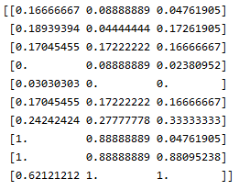

As you can see above in the output the values of all our input have been scaled down to fit within the numerical values 0 and 1. It’s also evident that there are no negative values as we expected.

Now you can build the keras model and compile as usual using stochastic gradient descent algorithm. However, you must be careful when using the fit() method. Make sure that we pass the normalized data through the method:

 Make sure you normalize the prediction inputs as well!



Here is the full code for the normalized training set version:



Now let’s take a look at the output of the above code. Your output should look something similar to the following:

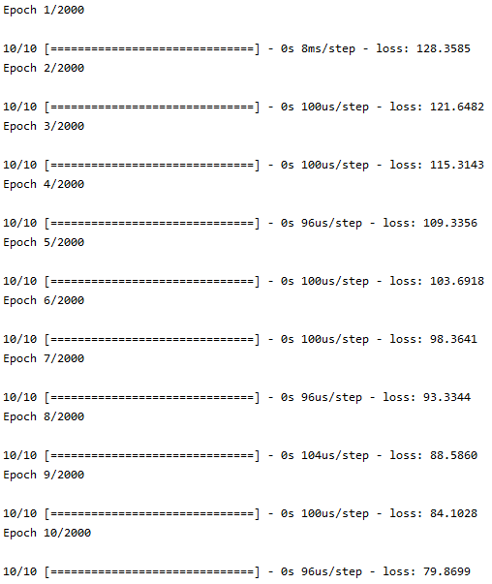

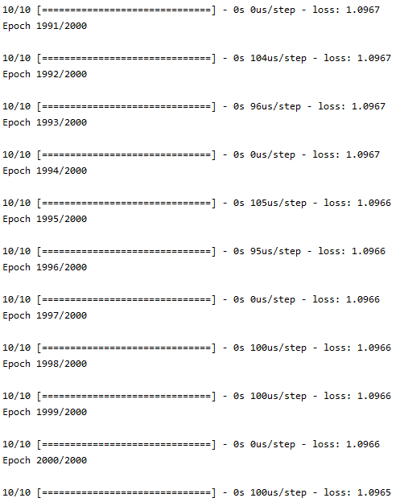



Figure 18: Multivariate linear regression prediction (Normalized)

You should immediately see the improvements of normalization on our model. Not only do we start at a smaller cost/loss value but also converge to the most optimal spot much faster. Additionally, we didn’t specify that the, our learning rate while creating our SGD instance was increased to 0.01. Compared to the learning rate of 0.0000001, the speed of our learning algorithm is day and night. This shows that not only are we able to help the algorithm choose correct paths during its iterations but also help increase the step sizes that it takes. Furthermore, our prediction when features weren’t scaled above, were greatly above the price that we would expect to not exceed which was $2.70. The prediction is now estimated at around $1.70 which is exactly what we want, once again providing evidence that normalization can have positive effects for optimizing our gradient descent algorithm.

**Standardizing Training Set:**

Similar to normalizing our data, to **standardize** our training set we must first set up the training set as per usual. So we’ll just use the same data set that we used above for comparison.

Now we must create an instance of the StandardScaler class.

Now we need to fit the data set using this scaler. Using the fit() method within the MinMaxScaler class computes the minimum and maximum values within the data set for later use:



After fitting the data we’ll need to now scale the data, we will use the transform() method within the MinMaxScaler class:

 Let’s now print the scaled inputs for our training set:

Your output should same as the following:

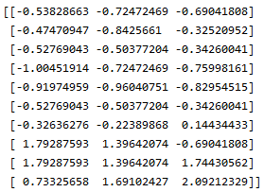

As you can see above in the output the values of all our input have been scaled down to fit within the –1 standard deviation and +1 standard deviation. You should straight away notice the difference compared to normalizing the training set as standardizing data have negative values while normalized values do not.



Make sure you standardize the prediction inputs as well!

Here is the full code for the standardized training set version:



Now let’s take a look at the output of the above code. Your output should look something similar to the following:

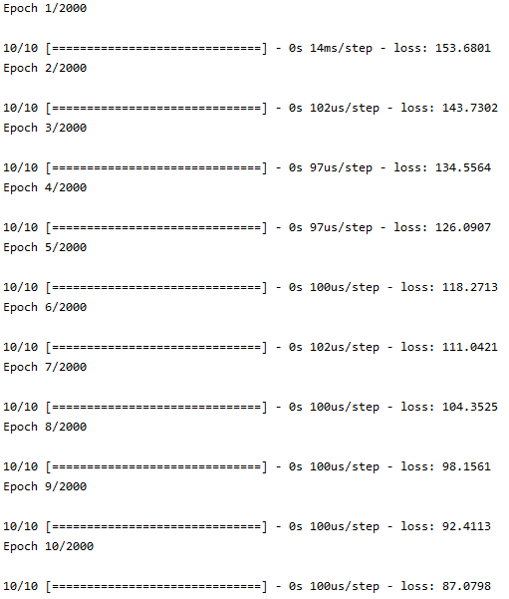

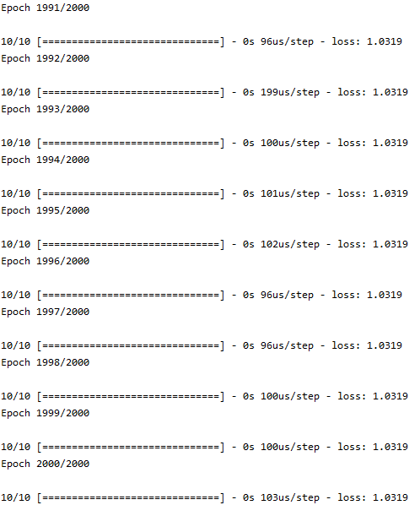



Figure 19: Multivariate linear regression prediction (Standardized)

As you can above from the running the code where the training set is standardized, the results are quite similar. However it seems that the standardized training set has optimized just a little faster and gave a lower price of our prediction inputs.

4.5 Summary and Exercises

In this chapter we mainly focused on extending our knowledge of linear regression by looking at an example where the output depended on multiple features rather than just one. We were able to generalize the hypothesis, cost function and the gradient descent algorithm for all and any linear regression models. This was done by using vectors and matrices to represent all features (xk) and parameters ($θ_{k}$) in one go within just two variables X and $θ$.

A new way to find the most optimal hypothesis was seen by using the normal equation. By using this equation we can go straight to the local minima without having to take an iterative approach which results in less costly computations unless there are substantial amount of features.

We also looked at data preprocessing. It was evident that data preprocessing is a powerful tool to as it allows us to access external files and gain data rather than having to hard code the numbers into the code ourselves. Furthermore, by preprocessing data specifically the step of feature scaling, we were able to optimize the gradient descent algorithm.

The idea of feature scaling and normalizing data was first introduced within the end of chapter 3, however, in this chapter we got to actually implement it within our code and learn its limitations as well. There is also another process similar to normalization called standardization and these can be grouped as feature scaling techniques. By using either one we can make the variances of all features to be within the same range. Furthermore, implementing this in our code and running it resulted in a gradient descent algorithm that converged much faster.

**Questions:**

1. What is multivariate linear regression?
2. Is there a way to find the most optimal hypothesis other than gradient descent, if so what is it?
3. Explain generally what the idea of the answer that you’ve given in question 2 is and explain the advantage of using that method over gradient descent
4. What is a possible problem that may approach when using the answer given within question 2?
5. What are two very powerful ways to optimize gradient descent?
6. Give the mathematical equations to the answers that you’ve chosen for question 5 and explain what they do
7. What are the limitations of your answers in question 5

**Answers:**

1. Multivariate linear regression is where the output depends on more than one variable. These variables are referred to as features in multivariate linear regression.
2. The normal equation can be used
3. The general idea of the normal equation is the same as solving optimization questions on a 2-dimensional function.

For example, to find the local optima’s for a parabola function, we can differentiate the function and find the position that the function has a gradient of 0. Then, we can either simply do the 2nd derivative test to find if it’s a maxima or a minima or even just compare the values next to the point of the optima.

The advantage of using the normal equation is that we can go straight to the optima rather than having to repetitively calculate making our computations less costly. However, this is only the case when there are only an appropriate amount of features.

1. Since the normal equation depends on the inverses of matrices to exist, it’s a possibility that we run into problems since not all matrices have an inverse. When a certain matrix doesn’t have an inverse it means that it is linearly dependent. Furthermore, it means that one or more features is a scalar multiple of another feature. For example if there are two features which describe the exact same thing just with different units. Thus, this problem is usually very simply fixed by removing redundant features within the training set.
2. We can normalize or standardize the training set
3. Normalize:

$$X_{normalize}=\frac{X-X_{min}}{{Range}_{X}}$$

$$=\frac{X-X_{min}}{X_{max}-X_{min}}$$

Standardization:

$$X_{standardize}=\frac{X-μ}{σ}$$

Normalizing data changes all training set inputs to be in the range of 0 and 1 meanwhile standardizing data changes all inputs to be in the range of –standard deviation and +standard deviation.

1. When using normalization the noise in our data can be amplified making prediction inaccurate. On the other hand since standardization relies heavily on the mean and standard deviation, any anomalies will can affect negatively on the reliability of standardizing training sets.
2. Classification using Logistic Regression

5.1 Introduction

You now have seen what the fundamentals of gradient descent are and why it’s so important in solving linear regression problems. Well, you’d be surprised to know that it doesn’t end at just linear regression. It’s also the key aspect in classification problems as well specifically; it is part of the logarithmic regression which we will see a little later.

Now you may be wandering why it’s called logistic *regression*? As we discovered in chapter 2, regression problems are mainly where the outputs are continuous meanwhile classification problems have outputs that are discrete. Well, although in solving classification models we will use logistic regression to output discrete values which are usually 0s’ and 1s’; it’s not specifically a classification algorithm on its own.

5.2 Classification Problem

So we already talked about the general idea of how we will approach classification problems. Once again, the basic idea is that we fit a logarithmic function to our training set.

Here are once again the data of students that passed or failed the test in relations to how long they studied that was shown in chapter 2.

|  |  |
| --- | --- |
| Total time of study for test | Pass or Fail |
| 1 | Fail |
| 2 | Fail |
| 5 | Fail |
| 10 | Fail |
| 16 | Pass |
| 17 | Fail |
| 22 | Pass |
| 25 | Pass |

Table 2: Classification problem training set

Once again by graphing this we get the following graph:



Figure 3: Classification problem training set plot

Now, you must remember that our example has only 1 feature and 2 possible outputs. This is obviously not going to be the case for every example, in fact as we keep mentioning, in the world that we live in, most things behave due to the change in multiple different variables.

We won’t show the graphing of the data that has multiple features, as dimensions above 3 are very hard to imagine. But, rather than having just 1 input feature, which is the hours that a certain student studied, we can also possibly look at things like how much of the actual time allocated for the test did that certain student use and so on.

Similarly, for the output we can further extend our example by saying that, rather than having just a simple pass or fail, we can also have outputs that describe the results of the test. For instance, we can say have the outputs as grades of A, B, C, D, etc. or we can also use GPA as the output unit.

Now graphing of a classification model with multiple outputs will look like the following:

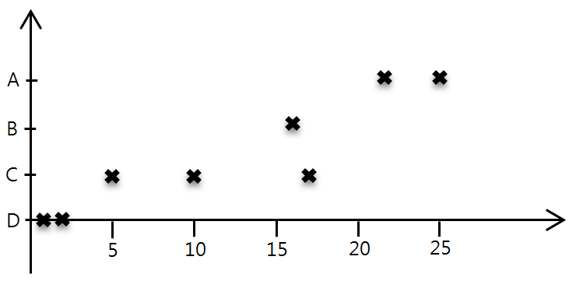

We can also graph this on one line by using either different colors or shapes

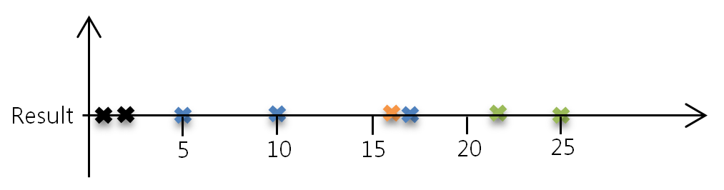

5.3 Can we use linear regression?

Well by reading the chapter title you’ve probably already figured out the answer to this the question. and you’re right the answer is no. But let’s actually see why that is.

So, some of you may be wandering why we can’t use a linear line to predict our data. Well, let’s go ahead and just assume that we are trying to use linear function on this graph, then, the graph would look something like this:



Now when looking at the graph above we can put some threshold to say that, when our inputs x cross or exceed this threshold then we can say they’ll pass. This would look something like this:



So around the 16 mark seems to be the threshold. Thus, our model can give us a decent prediction according to this graph. However, this becomes a problem when the balance of data is not as even as something like ours.

For example, assume that there is a student that passed who studied 60 hours. Our graphing of the new data would look like the following:

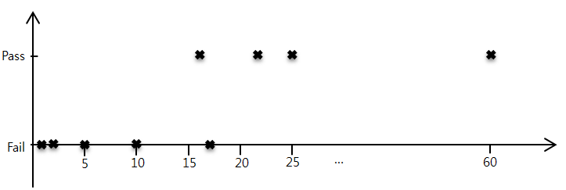

Now this is still fine, it’s still acting as we would expect. Now it’s true that even if you were to study thousands of hours, it doesn’t necessarily mean that you will pass the test, however, one who has studied more then double of everyone else and even the people who have passed would expect to pass the test.

But, here comes the problem, when we fit a linear model to our data let’s observe what happens:

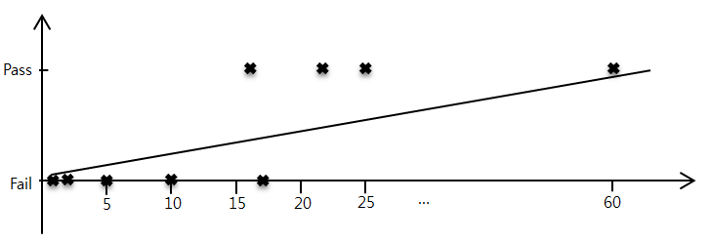

And also let’s estimate a threshold for our graph:

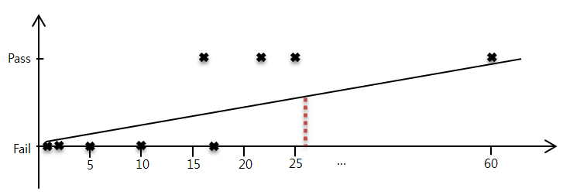

As you can see above, now we have a threshold value that’s between 25~30. That means that everyone who actually did pass and was predicted to pass during the model before this is now being predicted that they won’t pass. Thus you can see why linear models shouldn’t be used in classification problems as it is very sensitive to sparse data, making the actual machine learning algorithm a coin flip whether you get a more compact data or not.

Thus this is why we will need to use a logarithmic function. When fitting a logarithmic algorithm to our data it will look something like the following:



So how do we apply this? It turns out that we can follow a similar path that linear regression took to derive our algorithm.

5.4 Logistic regression Hypothesis

Let’s firstly discover what the hypothesis would be. We know that a logarithm function graphically looks like the following:

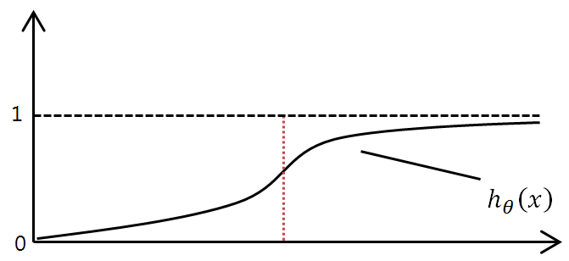

Before we derive the hypothesis something interesting to notice is that the hypothesis will map inputs values x to the output values y which are between 0 and 1. This lets us view the output values as probability.

We can also mathematically represent the output by the following:

$$P\left(y=0 \right| X:θ)+P \left(y=1 | X:θ\right)=1$$

All the above equation says is, Probability P that y the output equals to 0, given that X the inputs are parameterized by $θ$ plus the probability that y equals to 0, also given that X is parameterized by $θ$ equals to 1. All this means is that, the probability of the hypothesis predicting that a certain student will pass plus the probability of the hypothesis predicting that the same student will fail equals to 1. This should intuitively make sense, as a student only has two options of outcomes which is pass (1) or fail (0).

Therefore, we can represent the hypothesis as

$$0≤ h_{θ}\left(x\right)≤1$$

This means that predict the outputs as the following

$${if h}_{θ}\left(x\right)≥0.5 then y=1$$

$$else y=0$$

Now, we also know that the hypothesis must be a logistic function thus we can the hypothesis be the basic log function also known as the sigmoid function

$$h_{θ}\left(x\right)= \frac{1}{1+e^{-x}}$$

However, notice that this model has a limitation as x is only representing just 1 feature. So how do we make the hypothesis fit multiple features and parameters? Well, we know that the generalized hypothesis in linear regression is:

$$h_{θ}\left(x\right)= θ^{T}X$$

Hence, we can now say that:

$$h_{θ}\left(x\right)= {f(θ}^{T}X)$$

$$where f\left(i\right)= \frac{1}{1+e^{-i}}$$

Thus our new hypothesis for logistic regression would be:

$$h_{θ}\left(x\right)={f(θ}^{T}X)= \frac{1}{1+e^{-θ^{T}X}}$$

Now let’s go back to the idea that our hypothesis will predict:

$$y=1 {if h}_{θ}\left(x\right)≥0.5 else y=0$$

In our example of students’ results of the test, we can see that this will happen when x is round at about 17 hours. However, it’s always important to note that in machine learning questions the main goal focuses on finding the values of our parameters. In the case of a logistic regression problem with just 1 feature it won’t matter as we just need to cross a certain threshold to give a true or false answer; however, it becomes a little more interesting when dealing with multivariate logistic regression. So let’s go check out how parameters affect logistic regression.

Let’s assume that we have features x1 and x2. Thus our hypothesis will be the following equation:

$$h_{θ}\left(x\right)={f(θ}^{T}X)$$

$$=f(θ_{0}+θ_{1}x_{1}+θ_{2}x_{2})$$

And also assume that when we graph one against the other we get the following plot:

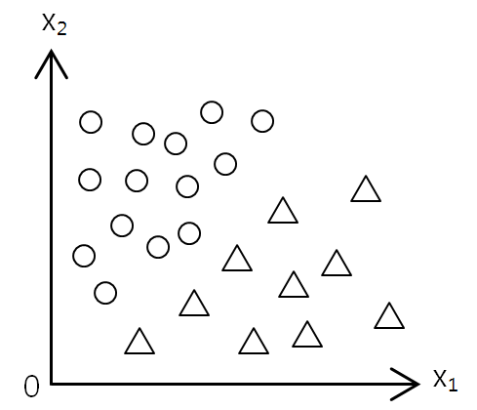

In the illustration above you should be able to immediately classify two sections of the graph. Even better we can for the moment assume that $θ_{0}=0$ and $θ_{1}$ = 1 and $θ_{2}=-1$

Thus our hypothesis will now be:

$$h_{θ}\left(x\right)=f\left(θ_{0}+θ_{1}x_{1}+θ_{2}x_{2}\right)=f\left(0+x_{1}-x_{2}\right)$$

Now let’s use that in this example y = 1 if

$$0+x_{1}-x_{2}≥0$$

Or

$$x_{1}-x_{2}≥0$$

Note that this is just an assumption and 0 is not always the center (in our student test score example, the center would be around 17.)

Therefore, by swapping the comparison operator with an equals sign like the following

$$x_{1}-x_{2}=0$$

With some simple rearranging we can make a linear line like the following

$$x_{1}= x_{2}$$

Thus when drawing this line on the graph we can get the following illustration

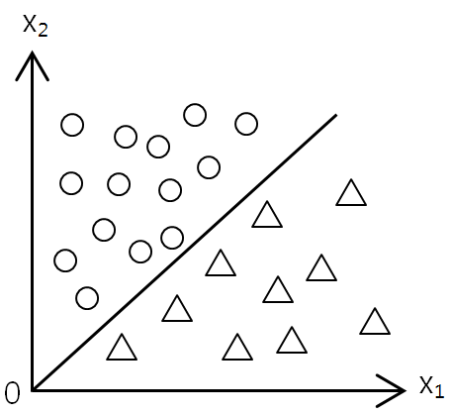

As you can see this is the line which divides the graph into two classification groups, this line is called the decision boundary. **This line is the point on the logistic graph that determines the answer of yes and no.**

When values are right on this line, realistically speaking, it’s near to impossible for both humans and machines to actually predict the ‘more correct’ outcome, but in coding form this will actually just depend on what the developer has done with the prediction algorithm.

Another thing to point out is that we can call the example above linearly separable since we can categorize the data with a single decision surface (linear line). This brings up the idea that data sets can also be non-linearly separable.

Here are some popular examples below

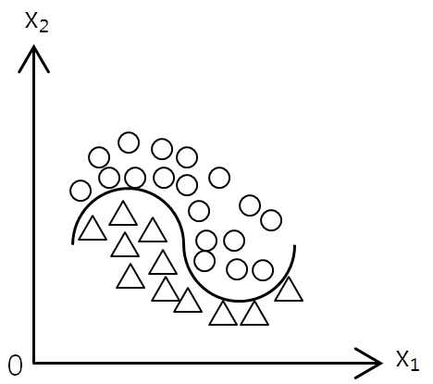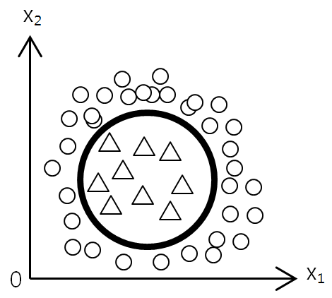

Hopefully you understand the relationship between our hypothesis and how our hypothesis behaves depending on the change of our parameters.

5.5 Cost function for logistic regression

Now that we’ve derived the hypothesis we need to know what the cost function is. We won’t derive the cost function in this book. The following is the cost function for logistic regression:

$$J\left(θ\right)= -\frac{1}{m}\sum_{i=1}^{m}{y^{(i)}logh_{θ}\left(x^{(i)}\right)}+(1-y^{\left(i\right)})log⁡(1-h_{θ}\left(x^{\left(i\right)}\right))$$

When $y^{\left(i\right)}=1$

$$J\left(θ\right)= -\frac{1}{m}\sum_{i=1}^{m}{1∙logh_{θ}\left(x^{(i)}\right)}+(1-1)log⁡(1-h_{θ}\left(x^{\left(i\right)}\right))$$

$$J\left(θ\right)= -\frac{1}{m}\sum_{i=1}^{m}{log\left(h_{θ}\left(x^{\left(i\right)}\right)\right)}$$

When $y^{\left(i\right)}=0$

$$J\left(θ\right)= -\frac{1}{m}\sum_{i=1}^{m}{0∙logh_{θ}\left(x^{(i)}\right)}+(1-0)log⁡(1-h_{θ}\left(x^{\left(i\right)}\right))$$

$$J\left(θ\right)= -\frac{1}{m}\sum_{i=1}^{m}{log⁡(1-h_{θ}\left(x^{\left(i\right)}\right)}$$

Thus we can also represent our cost function as:

$$J\left(θ\right)= \left\{\begin{aligned}-\frac{1}{m}\sum_{i=1}^{m}{log\left(h_{θ}\left(x^{\left(i\right)}\right)\right)} if { y}^{\left(i\right)}=1 \\ -\frac{1}{m}\sum_{i=1}^{m}{log\left({1-h}_{θ}\left(x^{\left(i\right)}\right)\right)} if y^{\left(i\right)}=0\end{aligned}\right.$$

However, when coding obviously the top equation is much preferred.

5.6 Gradient descent for logistic regression

First let’s figure out the differentiation of

$$f\left(i\right)=\frac{1}{1+e^{-i}}$$

Remember that this is our sigmoid function and this derivation will become very important when deriving our gradient descent algorithm.

Hence,

$$\frac{d}{di}f\left(i\right)= \frac{d}{di}\frac{1}{1+e^{-i}}$$

$$=\frac{d}{di}{\left(1+e^{-i}\right)}^{-1}$$

Now by letting $e^{-i}=u$ and using the chain rule we can represent the above as the following

$$\frac{d}{du}{\left(1+u\right)}^{-1}∙\frac{d}{di}u$$

$$=-{\left(1+u\right)}^{-2}∙-e^{-i}$$

$$=-{\left(1+e^{-i}\right)}^{-2}∙-e^{-i}$$

$$= \frac{e^{-i}}{{\left(1+e^{-i}\right)}^{2}}=\frac{1}{1+e^{-i}}∙\frac{e^{-i}}{1+e^{-i}}$$

Now by using a little trick we can set the above equal to

$$\frac{1}{1+e^{-i}}∙\frac{{1+e}^{-i}-1}{1+e^{-i}}$$

$$=\frac{1}{1+e^{-i}}∙\left(\frac{{1+e}^{-i}}{1+e^{-i}}-\frac{1}{1+e^{-i}}\right)$$

$$=\frac{1}{1+e^{-i}}∙\left(1-\frac{1}{1+e^{-i}}\right)$$

$$= f\left(i\right)∙(1-f\left(i\right))$$

Now that we have differentiated our sigmoid function let’s go ahead and derive the gradient descent algorithm for logistic regression

$$θ_{k}=θ_{k}-α\frac{∂}{∂θ_{k}}J\left(θ\right)$$

Thus by subbing in $J\left(θ\right)$ we get:

$$θ_{k}=θ_{k}-α∙ -\frac{1}{m}\frac{∂}{∂θ_{k}}\sum_{i=1}^{m}{y^{(i)}logh_{θ}\left(x^{(i)}\right)}+(1-y^{\left(i\right)})log⁡(1-h_{θ}\left(x^{\left(i\right)}\right))$$

$$=θ_{k}+α\frac{1}{m}\frac{∂}{∂θ_{k}}\sum_{i=1}^{m}{y^{\left(i\right)}logh_{θ}\left(x^{\left(i\right)}\right)}+\left(1-y^{\left(i\right)}\right)\log\left(1-h_{θ}\left(x^{\left(i\right)}\right)\right)$$

Let’s first figure out what is

$$\frac{∂}{∂θ_{k}}J\left(θ\right)$$

To differentiate this term, remember that summations do not affect the derivative so we can quickly take out the summation differentiate the term inside and put the summation back when finished.

So let’s

$$\frac{∂}{∂θ_{k}}(y^{(i)}logh_{θ}\left(x^{\left(i\right)}\right)+(1-y^{\left(i\right)})log⁡(1-h_{θ}\left(x^{\left(i\right)}\right))$$

Using the chain rule we can get

$$=y^{\left(i\right)}\left( \frac{1}{h_{θ}\left(x^{\left(i\right)}\right)}\right)∙ \frac{∂}{∂θ_{k}}h_{θ}\left(x^{\left(i\right)}\right)-\left(1-y^{\left(i\right)}\right)∙\left(\frac{1}{{1-h}_{θ}\left(x^{\left(i\right)}\right)}\right)∙\frac{∂}{∂θ_{k}}h_{θ}\left(x^{\left(i\right)}\right)$$

$$=\frac{∂}{∂θ_{k}}h_{θ}\left(x^{\left(i\right)}\right)∙\left(y^{\left(i\right)}\left( \frac{1}{h_{θ}\left(x^{\left(i\right)}\right)}\right)-\left(1-y^{\left(i\right)}\right)∙\left(\frac{1}{{1-h}_{θ}\left(x^{\left(i\right)}\right)}\right)\right)$$

Now before we go any further let’s figure out

$$\frac{∂}{∂θ_{k}}h_{θ}\left(x^{\left(i\right)}\right)$$

We know that

$$\frac{∂}{∂θ_{k}}h_{θ}\left(x^{\left(i\right)}\right)=\frac{∂}{∂θ_{k}}\frac{1}{1+e^{-θ^{T}X}}$$

Now remember that this is just the sigmoid function however now we have a term

$$θ^{T}X which also depends on θ_{k}$$

Thus we can represent

$$\frac{∂}{∂θ_{k}}\frac{1}{1+e^{-θ^{T}X}}$$

By using the chain rule once again

$$= h_{θ}\left(x^{\left(i\right)}\right)∙\left(1-h_{θ}\left(x^{\left(i\right)}\right)\right)∙\frac{∂}{∂θ_{k}}\left(θ^{T}X\right)$$

Thus we can now sub this back into the derivative of cost function formula to get

$$\left(y^{\left(i\right)}\left( \frac{1}{h_{θ}\left(x^{\left(i\right)}\right)}\right)-\left(1-y^{\left(i\right)}\right)∙\left(\frac{1}{{1-h}_{θ}\left(x^{\left(i\right)}\right)}\right)\right)∙h_{θ}\left(x^{\left(i\right)}\right)∙\left(1-h_{θ}\left(x^{\left(i\right)}\right)\right)∙\frac{∂}{∂θ_{k}}\left(θ^{T}X\right)$$

$$=\left( y^{\left(i\right)}∙\frac{\left(h_{θ}\left(x^{\left(i\right)}\right)\right)∙\left(1-h_{θ}\left(x^{\left(i\right)}\right)\right)}{h_{θ}\left(x^{\left(i\right)}\right)}-\left(1-y^{\left(i\right)}\right)∙\frac{\left(h_{θ}\left(x^{\left(i\right)}\right)\right)∙\left(1-h_{θ}\left(x^{\left(i\right)}\right)\right)}{1-h_{θ}\left(x^{\left(i\right)}\right)}\right)∙\frac{∂}{∂θ_{k}}\left(θ^{T}X\right)$$

$$= \left(y^{\left(i\right)}\left(1-h_{θ}\left(x^{\left(i\right)}\right)\right)-\left(1-y^{\left(i\right)}\right)\left(h_{θ}\left(x^{\left(i\right)}\right)\right)\right)∙\frac{∂}{∂θ_{k}}\left(θ^{T}X\right)$$

$$={(y}^{\left(i\right)}-y^{\left(i\right)}h_{θ}\left(x^{\left(i\right)}\right)-h_{θ}\left(x^{\left(i\right)}\right)+y^{\left(i\right)}h_{θ}\left(x^{\left(i\right)}\right))∙\frac{∂}{∂θ_{k}}\left(θ^{T}X\right)$$

$$={(y}^{\left(i\right)}-h_{θ}\left(x^{\left(i\right)}\right))∙\frac{∂}{∂θ_{k}}\left(θ^{T}X\right)$$

$$={(y}^{\left(i\right)}-h_{θ}\left(x^{\left(i\right)}\right))∙x_{k}^{i}$$

Therefore, we can finally sub this back into our derivation of gradient descent where

$$θ_{k}=θ_{k}-α\frac{∂}{∂θ_{k}}J\left(θ\right)$$

$$= θ_{k}-α∙-\frac{1}{m}\frac{∂}{∂θ_{k}}\sum_{i=1}^{m}{y^{\left(i\right)}logh_{θ}\left(x^{\left(i\right)}\right)}+\left(1-y^{\left(i\right)}\right)\log\left(1-h_{θ}\left(x^{\left(i\right)}\right)\right)$$

$$=θ_{k}+α∙\frac{1}{m}\sum_{i=1}^{m}{{(y}^{\left(i\right)}-h_{θ}\left(x^{\left(i\right)}\right))∙x_{k}^{i}}$$

$$=θ_{k}-α∙\frac{1}{m}\sum_{i=1}^{m}{\left(h_{θ}\left(x^{\left(i\right)}\right)-y^{\left(i\right)}\right)∙x_{k}^{i}}$$

Now notice that this is actually the exact same gradient descent algorithm for our generalized linear regression.

Now let’s go ahead and implement this in our code.

5.7 Solving logistic regression problem with Code

Step 1: Here are all the imports necessary for the following code

Step 2: We need to now create our training set

**[Additional information]** Multivariate logistic regression

In our example we are only dealing with a 1 dimensional input and output. However, in more complex cases, this is not going to be the case since we can have both multiple inputs and outputs.

To code multivariate data sets we you will need to make sure that you create in a matrix form using numpy arrays. This should be done like how we did it chapter 4. An example is shown below:

Step 3: Now that we created our training set we must create our keras model

Step 4: Now we will add the layer. We will use the Dense() class once again however this time there will be an extra argument passed.

This argument is called ‘activation’, what this variable determines is what activation functions the keras model will use. If we don’t specify the activation then it’s automatically set to ‘linear’ thus, the reason why we didn’t need to specify during linear regression. Furthermore, we’ll be using the sigmoid function for our activation. Here is how it’s done:

Step 5: We now need to make our optimizer. Now remember that the gradient descent algorithm for both the logistic and linear regressions is the same thus we can just use the same SGD optimizer as the examples within chapter 3 and 4.

Step 6: When compiling our model we need to make sure that our ‘loss’ is set to the correct keyword. In this example we’ll be using ‘binary_crossentropy’. We will also display an additional metric called ‘binary_accuracy’.

**[Additional information]** Cross-entropy

Cross-entropy is most often referred to as the loss function used by machine learning engineers when predicting classification models. It calculates the difference between two probability distributions, to put simply, cross-entropy determines how ‘far-away’ the prediction is from the true distribution which is the actual output within the training set.

Binary cross-entropy on the other hand, is used when your machine is trying to decide a concrete ‘yes’ or ‘no’ answer on the input coming in. This is the reason that it’s called a *Binary* cross-entropy since there are only 2 options true or false. This specific type of cross-entropy is also referred to as log loss, and is actually the exact equation of the cost function that we derived above for our logistic regression.

Thus this is what our code should look like:

Step 7: We will now fit the model

Step 8: We will now graph the cost function and also predict some data that aren’t within the training set.

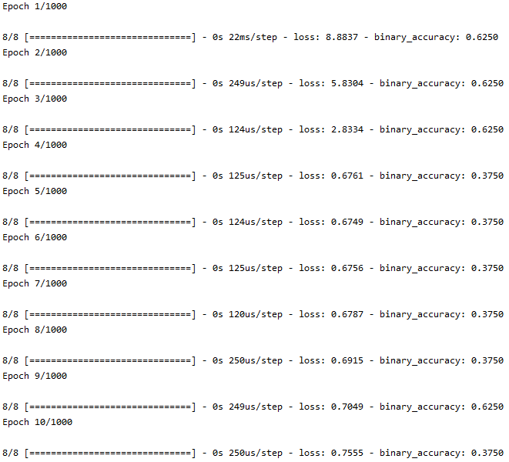Your output should look like the following:

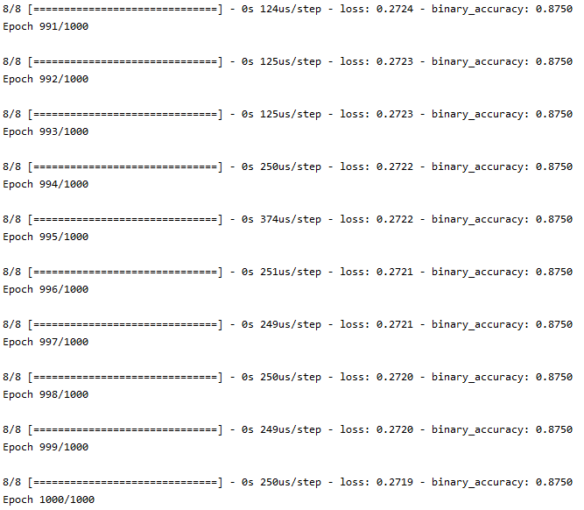

Figure 20: Logistic regression algorithm output

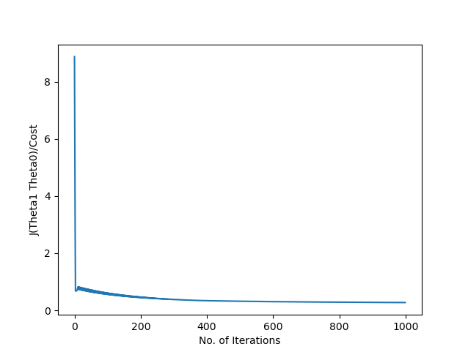

Figure 21: Logistic regression cost function plot

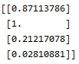

Figure 22: Logistic regression prediction

As you can see above from figure 20 and 21 our gradient descent seems to be working as we expected as the loss/cost is decreasing over time. You can also see in figure 20 that the binary accuracy is shown. You can immediately see that the accuracy during the start starts at around 0.6250, decreases to 0.3750 and finally back up and seems to have converged to 0.8750 which is higher than what we started off with. Thus is seems that everything is working correctly or at least what we assumed it would do so.

Here is the full code from steps 1~8:

|  |
| --- |
|  |
|  | from keras.models import Sequential  from keras.layers import Dense |
|  | from keras.optimizers import SGD |
|  | import matplotlib.pyplot as plt |
|  | import numpy as np |
|  | from sklearn.preprocessing import MinMaxScaler |
|  |  |
|  | # Training set |
|  |  |
|  | train_x = np.array([1, 2, 5, 10, 16, 17, 22, 25]) |
|  | train_y = np.array([0, 0, 0, 0, 1, 0, 1, 1]) |
|  |  |
|  | # Create Keras model |
|  | model = Sequential()  # Add Layer to our model |
|  | model.add(Dense(1, input_dim=1, activation='sigmoid')) |
|  |  |
|  | # Gradient descent algorithm |
|  | sgd = SGD(0.05)  # Compile our model |
|  |  |
|  | model.compile(loss='binary_crossentropy', optimizer=sgd |
|  | , metrics=['binary_accuracy'])  # Make our model learn |
|  | history = model.fit(train_x, train_y, epochs=1000)  # Plot cost function |
|  |  |
|  | plt.plot(history.history['loss']) |
|  | plt.xlabel("No. of Iterations") |
|  | plt.ylabel("J(Theta1 Theta0)/Cost") |
|  | plt.show()  # Predict |
|  |  |
|  | predict = np.array([[23], [300], [10], [1]]) |
|  | print(model.predict(predict)) |

5.8 Summary and Exercises

In this chapter we finally looked at a different type of a supervised learning problem called the classification problem. We found out that we couldn’t apply classification problems with linear models as it gave very incorrect predictions when data is sparse. Hence, we realized that we could use the logistic or sigmoid regression on the data and it would give us an accurate threshold called the decision boundary which determined the output of our hypothesis.

It’s important to remember that although the decision boundary is a point or in this case certain values of our inputs that help classify other inputs as a yes or no answer, you must remember that it can be translated into a function when graphing all training inputs against each other (For example if you have two inputsx1 and x2 then you can graph x1 vs x2 graph where one is the y-axis and the other is the x-axis and find that there will be a function that divides the two clusters of data into its own categories).

We then studied the mathematics behind the logistic regression to see how our cost function has changed and later realized that the although with the changed cost function it had no effect on the gradient descent algorithm.

Then we applied this to code by specifying the activation as sigmoid and using the binary_crossentropy loss function giving us a true or false (0 or 1) output. Additionally, we can look at the outputs of future inputs as probabilities (The probability of an input being 1 for example). This will give us an output number between 0 and 1. Hence, we can expect that if the output is over 0.5 than it’s true and vice versa when under 0.5.

**Exercises:**

1. Why can we not use linear regression on classification problems?
2. Then what function/regression should we use and how is this certain function represented mathematically? (Following on from question 1)
3. What is the decision boundary?
4. Thus, what is gradient descent algorithm doing in logistic regression? (In another words what is being optimized?)

**Answers:**

1. We cannot use linear models on classification problems as it is very inaccurate when the training set is sparse.
2. The function that is used in solving classification problems are called logistic or sigmoid functions they look like the following:
$$f\left(i\right)=\frac{1}{1+e^{-i}}$$

3. The decision boundary describes the threshold point or value of input that determines whether the output is a certain category.
4. In logistic regression, the gradient descent algorithm optimized the parameters for the best decision boundary

Appendix

There are multiple write and run code for machine learning. Here we will explore a total of 3 different ways.

**Using Python IDLE only:**

1. Installing python

Step 1: Firstly let’s install python. Go to python.org in your web browser, you will be directed to a page that looks like the following

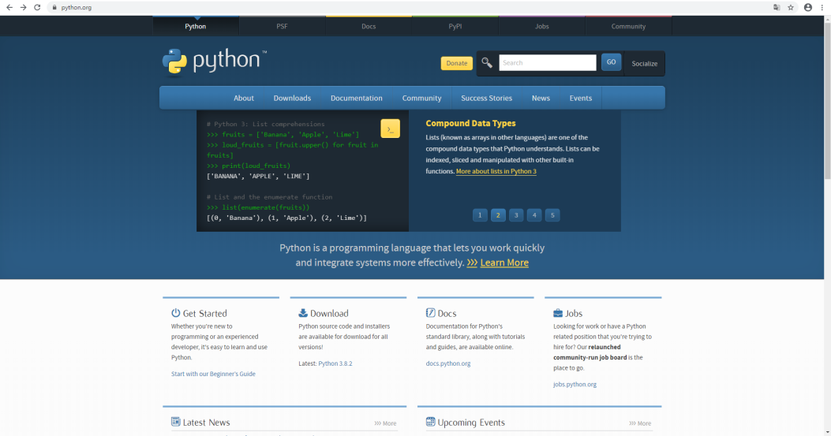

Step 2: Now hover over the Downloads section

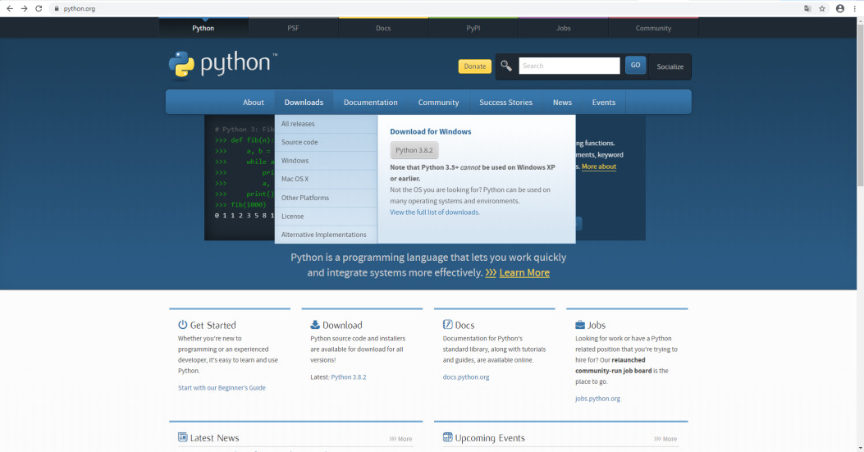

Step 3.1.1 **(Windows users only!)**: Now click the ‘All releases’ section



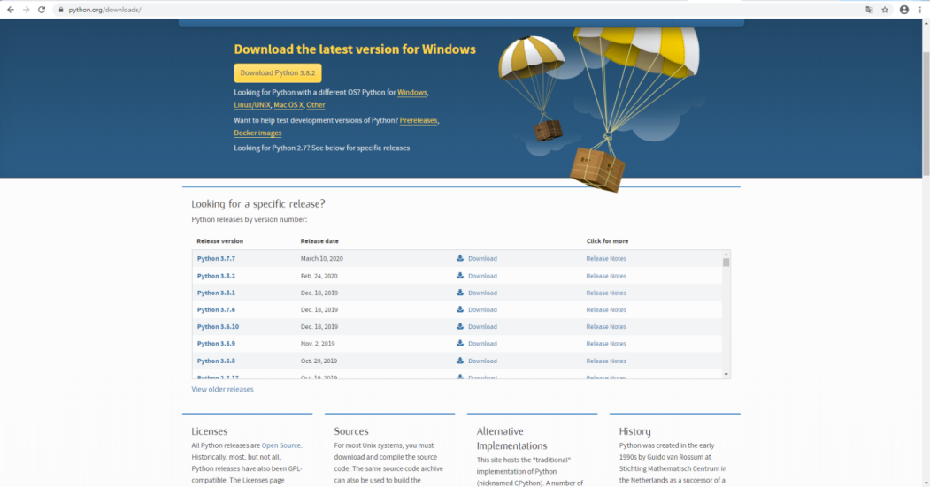Step 3.1.2 **(Windows users only!)**: You should now be directed to the following page

Step 3.1.3 **(Windows users only!)**: From here scroll down and click download for any release version of python 3.6 or 3.7.



Step 3.1.4 **(Windows users only!)**: You should now be led to the following page

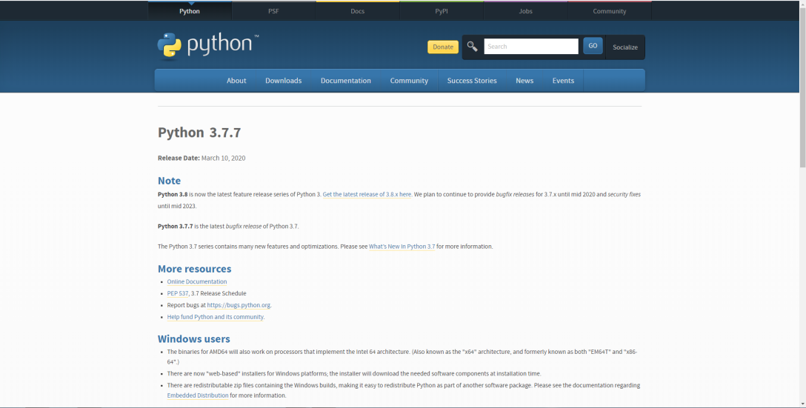

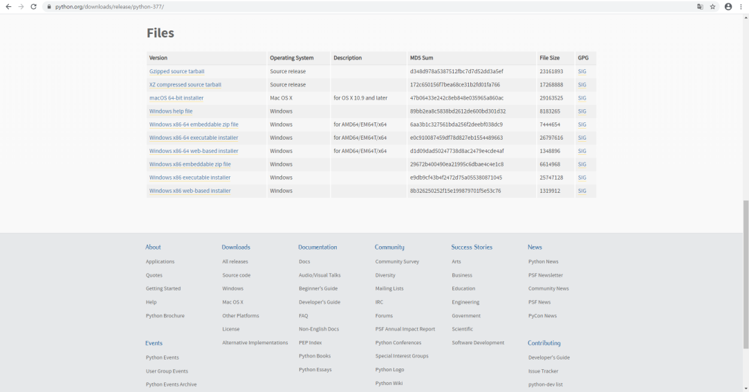Step 3.1.5 **(Windows users only!)**: You now need to scroll down to the section that shows all the possible downloads

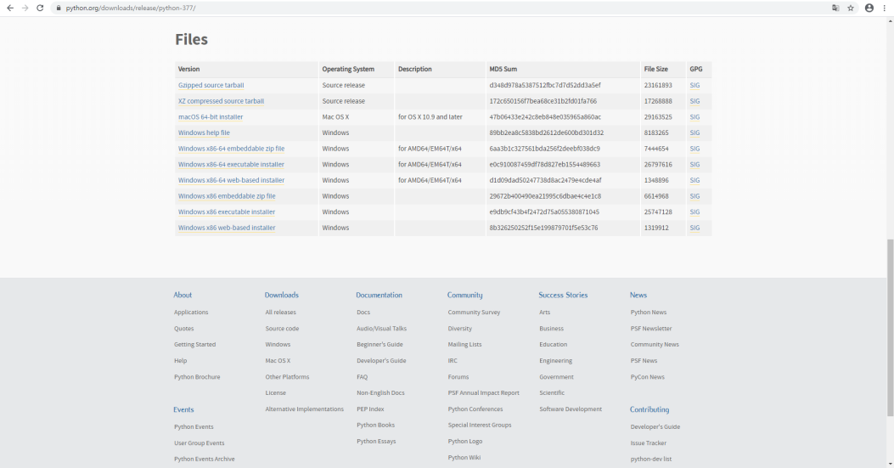Step 3.1.5 **(Windows users only!)**: From here you will need to download the correct version. Click where it says ‘Windows x86-64 executable installer’

Step 3.2.1 **(MacOS Users Only)**: For MacOS users you will need to click to the ‘MacOS X’ section:



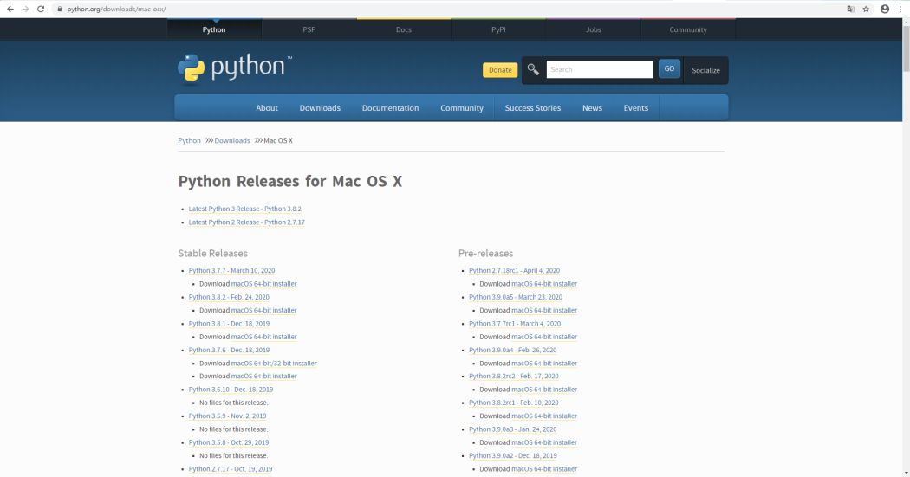Step 3.2.2 **(MacOS Users Only)**: After clicking the ‘MacOS X’ section you should now be directed to this page.

Step 3.2.3 **(MacOS Users Only)**: You will now need to click the download button for the python version if 3.7.7. After clicking this button the download should automatically start happening.

Step 4: Now that the installer has downloaded, run the installer. Once running the installer, the installer program will open and it should look something similar to this the following:

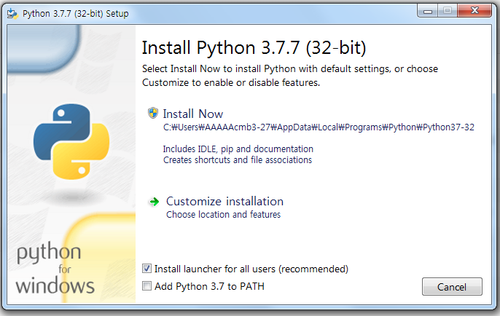

Step 5: Now once the setup is open you should tick the ‘Add Python 3.7 to PATH’ box for an easier installation.

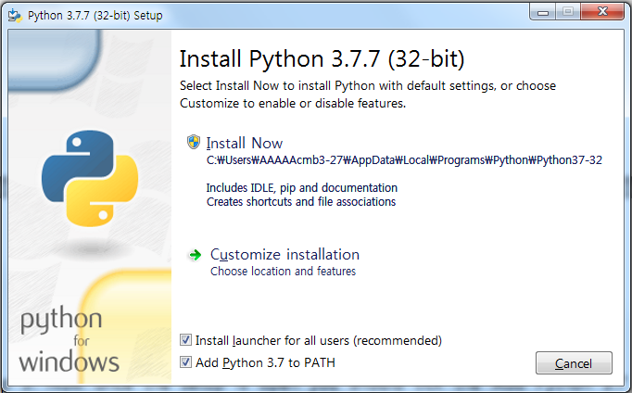

Step 6.1: For an easy and default installation you can hit the ‘Install Now’ section:

Step 6.2: If you have followed **step 6.1** then you can skip to **step 7**. Here we’ll show you how to customize your installation. Firstly, click the ‘Customize installation’ section



Step 6.3: You should now be led to this section of the installation. These following features (that comes ticked) are all quite important, so it is recommended that you do not touch this page. If you’re going to play around with the settings here, **DO NOT** untick the ‘pip’, ‘td/tk and IDLE’, ‘Documentation’, and ‘py launcher’ as these will be important when installing and using tensorlfow. Once you’ve customized you can go ahead can press the ‘Next’ button

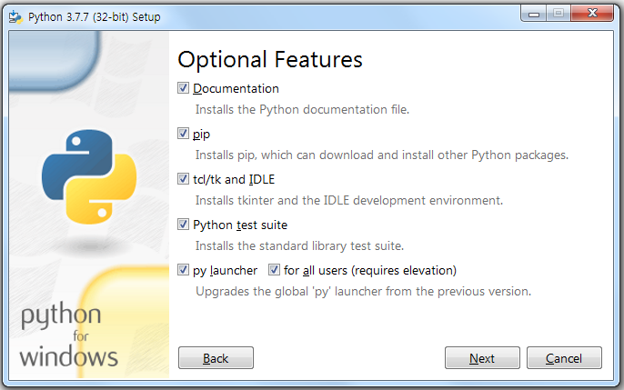

Step 6.4: You’ll now be lead to the following. Here you can customize your settings and also choose the location of your installation. Once finished click the ‘Install’ button.

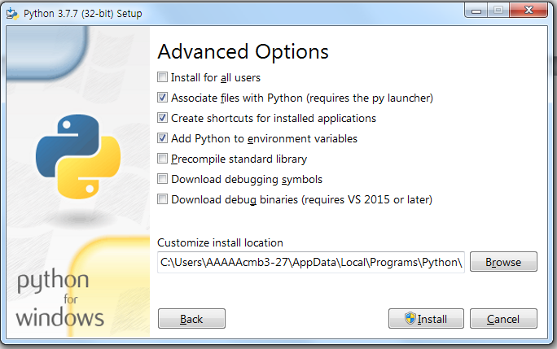

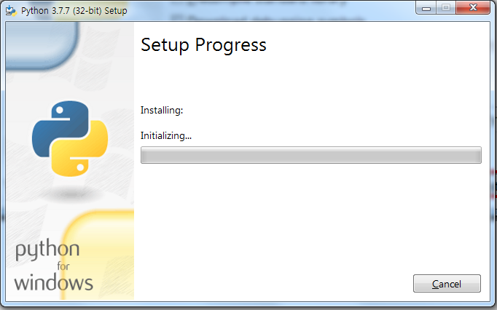Step 7: You will now see the setup program automatically install python for you. Wait until the progression bar is filled up and you will be directed to another screen

Step 8: Once finished you should now see the ‘Setup was successful’ page. If so click the ‘close’ button and go to the tensorflow setup tutorial.



1. Installing Tensorflow, Numpy, Matplotlib, Keras

Step 1: We will now install Tensorflow and keras if necessary. Open up command prompt (cmd), this is done by going to your windows search bar and typing in cmd. Once open it should look similar to the following:

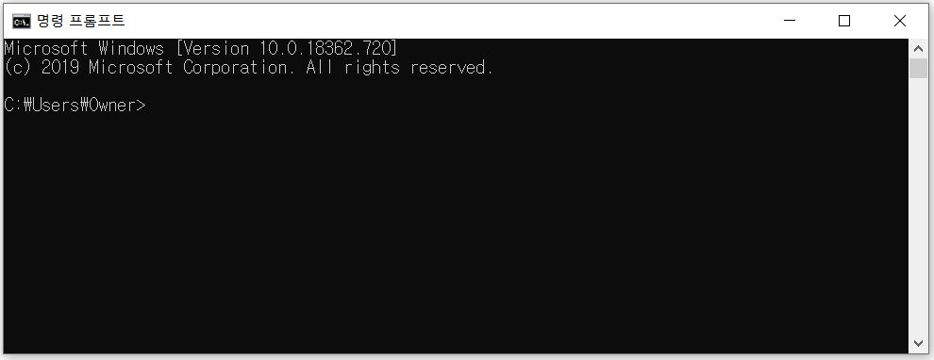

Step 2: To ensure that python has been installed type ‘python’:

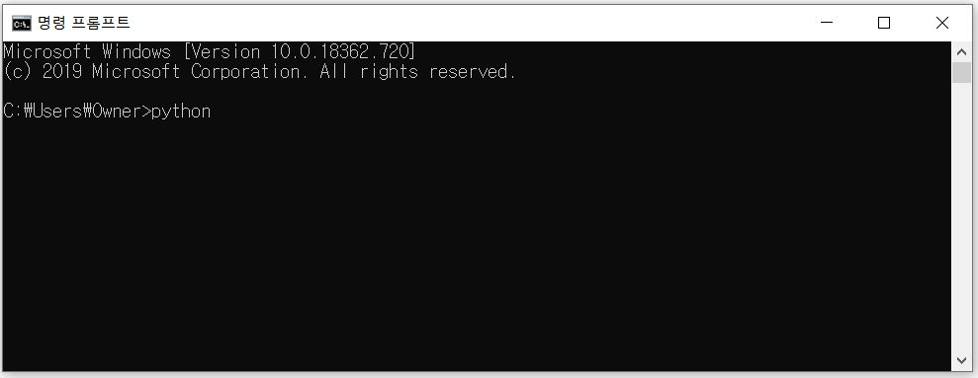

Step 3: Now press enter and the output should look similar as the following. Make sure that the version of python is of any 3.6 or 3.7 versions

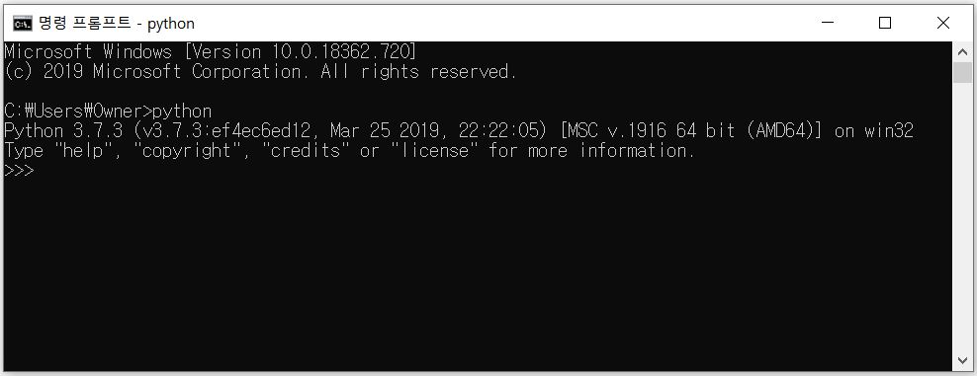

Step 4.1: Let’s now install tensorflow. Now type ‘quit()’ and enter. Then type ‘pip install tensorflow’.

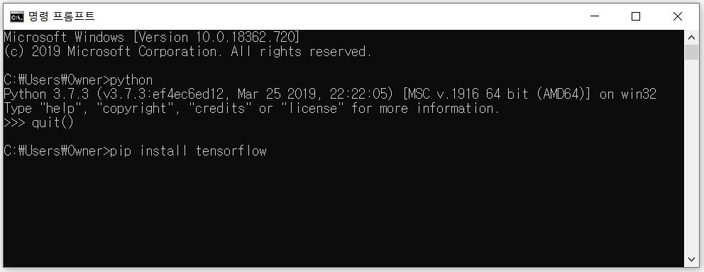

Step 4.2: If your system is using a graphics card you will need to install the version of tensorflow that uses the gpu. This is simply done by typing ‘pip install tensorflow –gpu’

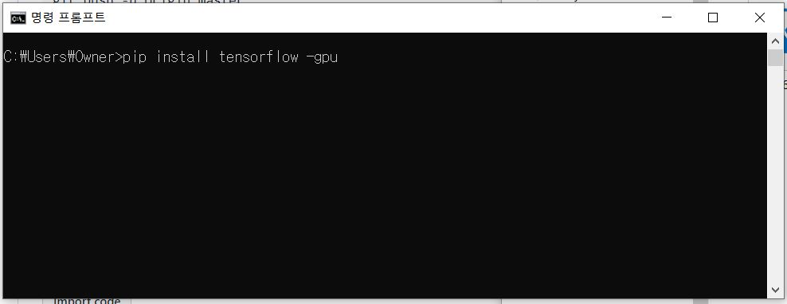

Step 5: Once pressing ‘Enter’, tensorflow should immediately start installing. A progress bar will be shown similar to the following

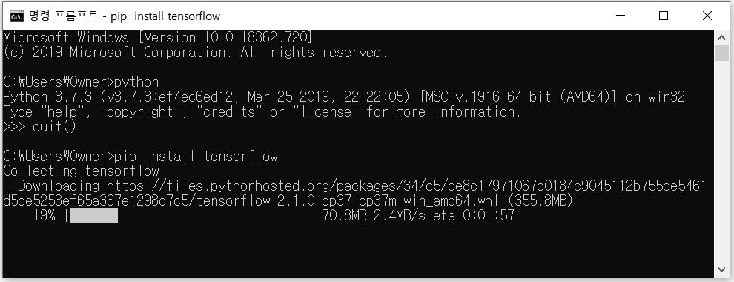

Step 6: Once finished cmd should output that Tensorflow has been successfully installed. Your output will look similar to the following:

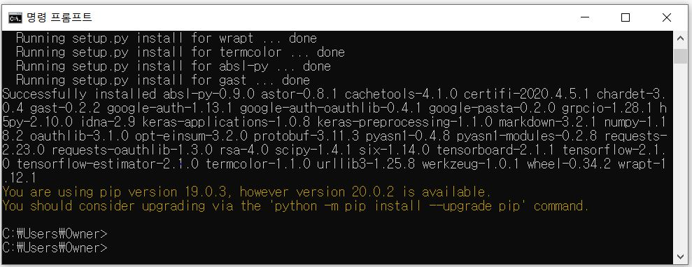

Step 6.1: This step is not a necessity, however if you get an similar error shown in the blue box above in step 6, this just means that your pip version is out of date. To update this you can simply type ‘pip install –-user --upgrade pip’

This should immediately start uninstalling the old version of pip and then install the newest version of pip. You will see a similar progress bar to the one above when installing tensorflow. Once the installing of pip is completed you can check once again by typing ‘pip install –-user --upgrade pip’. Once inputting, cmd will output that the ‘Requirement is already up-to-date. This is shown below:

[Additional information] PIP

To put simply, PIP is just a package/module manager for python. Using pip within cmd or the terminal (depending on what operating system you’re using) we can access and install all kinds of packages as long as your system has access to the internet.

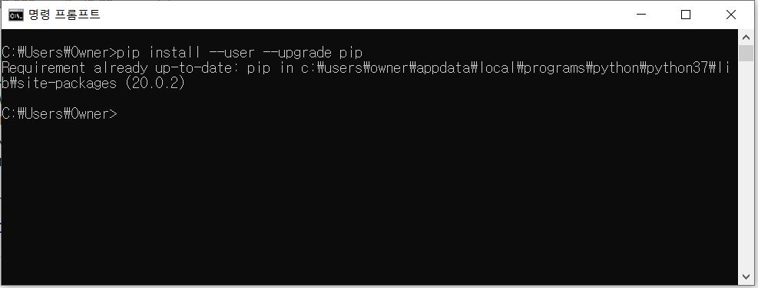

Step 7: We will now once again use pip to install both the numpy and matplotlib packages.

To install you will need to type ‘pip install numpy’ and ‘pip install matplotlib’. Note that you must type these one by one as pip doesn’t install multiple packages at once. Make sure to check that they have been installed successfully

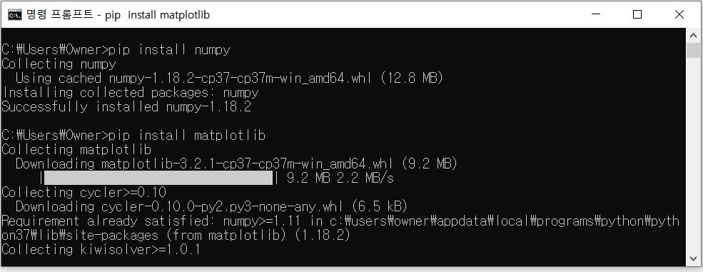

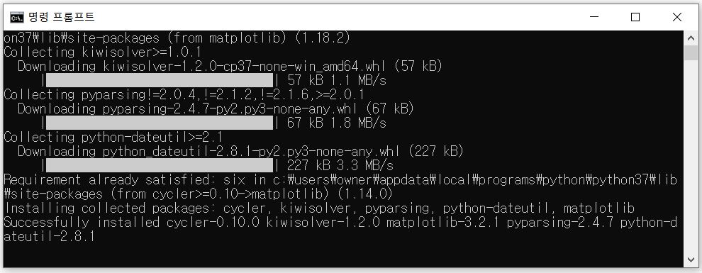

Step 7.1: There is a common installation error when installing numpy. There will be an error in red stating that the ‘setuptools’ require for ‘tensorboard’ is out of date. To fix this problem you can easily just type and enter ‘pip install setuptools –upgrade’. Once updated you can type it again to check if it’s up-to-date:

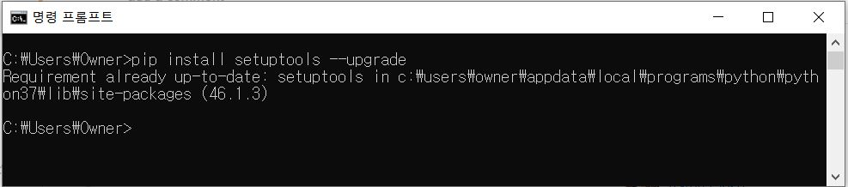

If the setup was successful make sure to ‘pip install numpy’ again just in case tensorflow has not been setup correctly with numpy.

Step 8: Once finishing all the previous steps you can type ‘pip list’ to check if you’ve missed any packages. Now we’re ready to start coding in python. At this point if you’re using python 3.6 than tensorflow v1 should’ve installed meanwhile for python 3.7 tensorflow v2 will have installed. Keras is built into tensorflow v2, thus make sure install Keras by ‘pip install keras’ if using tensorflow v1.

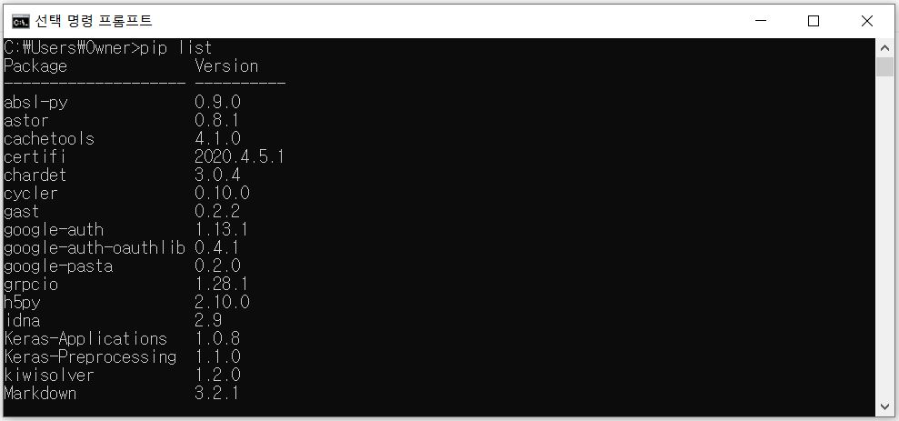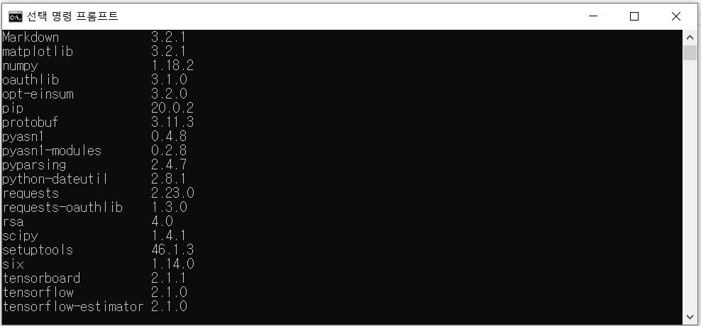

1. Using python IDLE

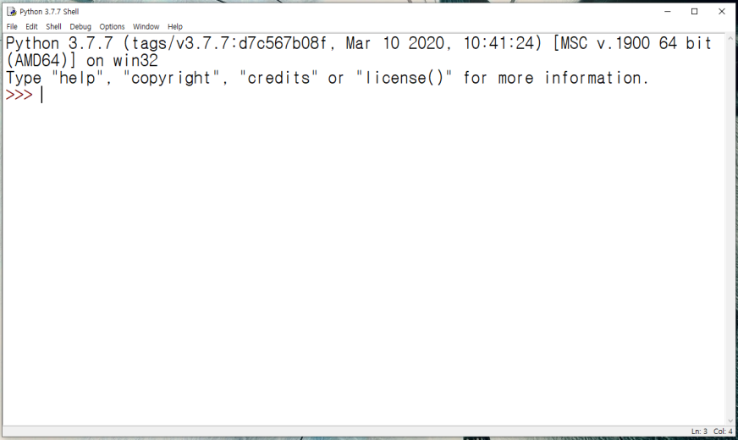Step 1: Go to your windows search bar and type ‘IDLE’. You should see a program called IDLE (Python 3.7 64-bit) or IDLE (Python 3.6 64-bit). Open this program and you’re a program should’ve open which looks like this:

What has been opened in step 1 is called the python shell. Here you can execute code line by line like the following:

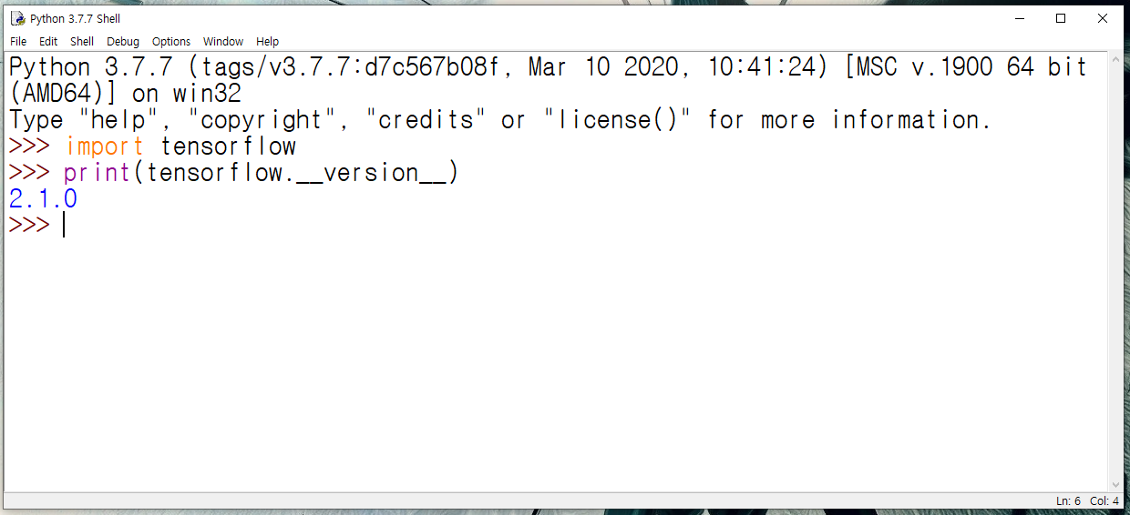

Step 2: But we want to write scripts thus you can either press ‘Ctrl + n’ or do the following steps to open a new script file:

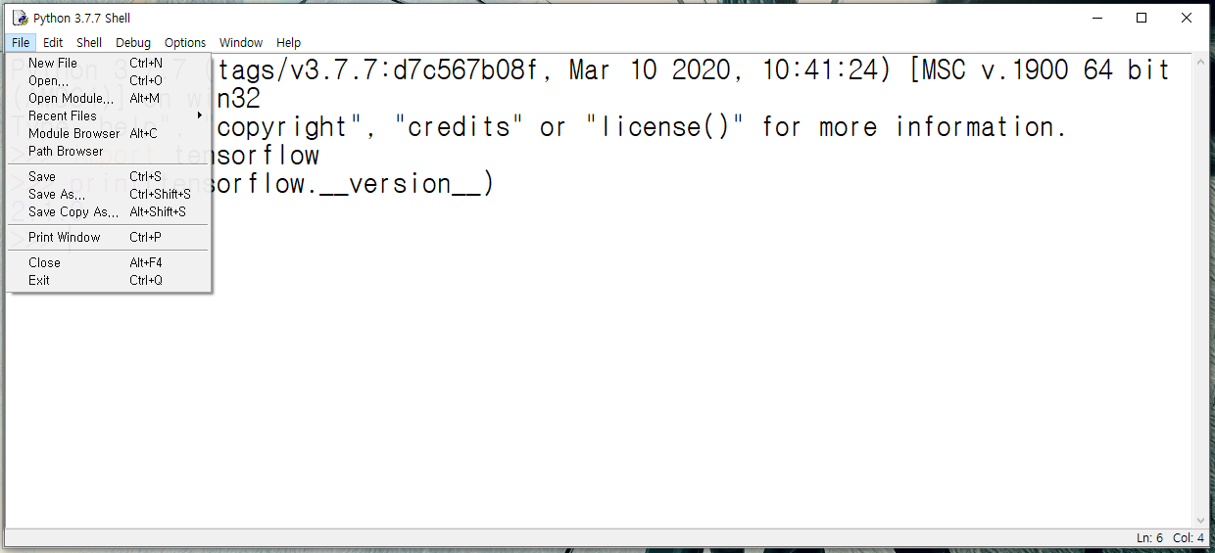

Step 3: Now a new and blank script file should open. This should open on top of your shell as well.

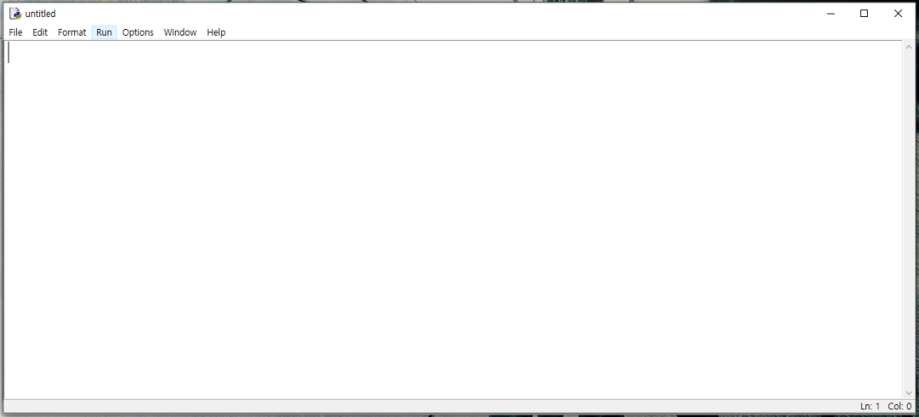

Step 4: Now you can write all the code you want here before running

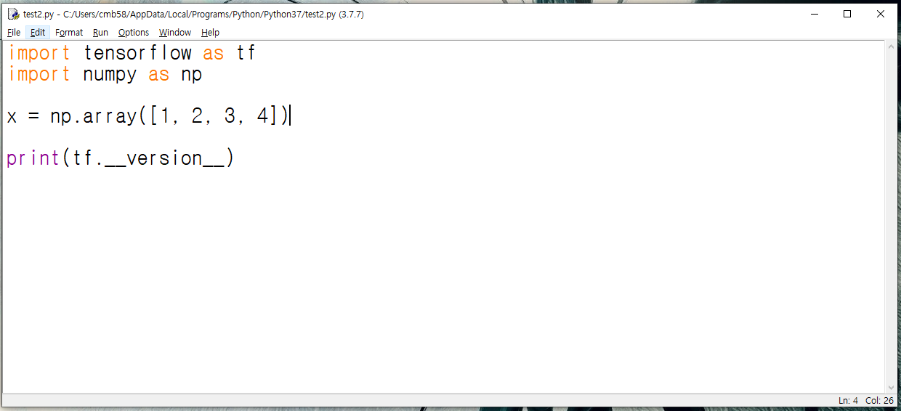

Step 5: Now you can run the script by hovering over the ‘Run’ section and pressing ‘Run module’ or you can simply just press F5.

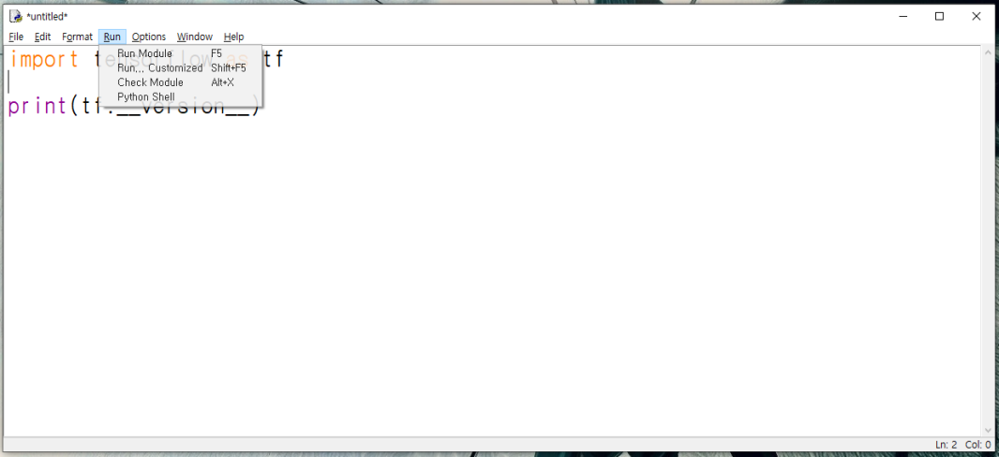

Step 6: You will now be prompted to save the file. Press ‘yes’ and save the file wherever you like.

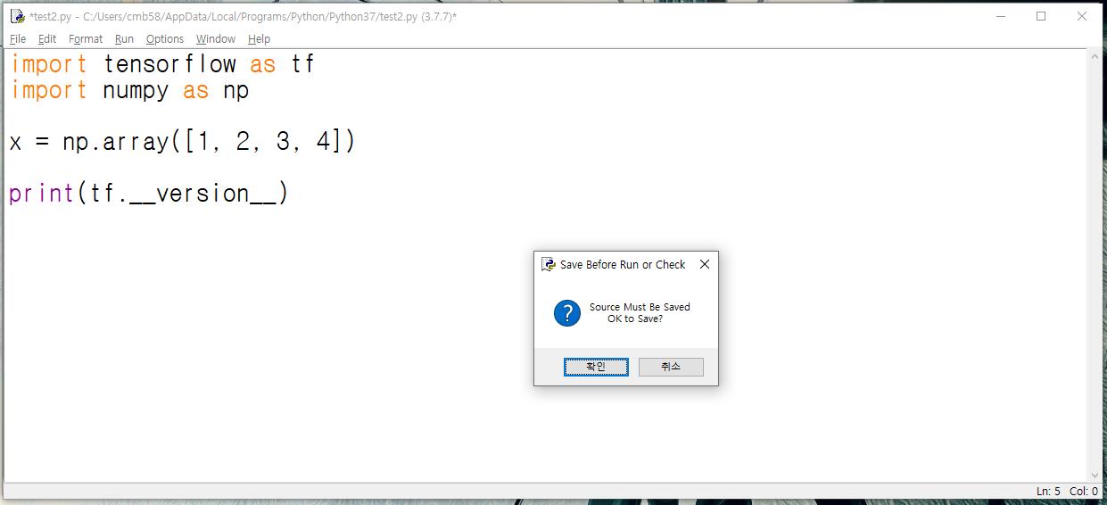

Step 7: After saving the code/script will run. The output will be shown in the shell like the following:

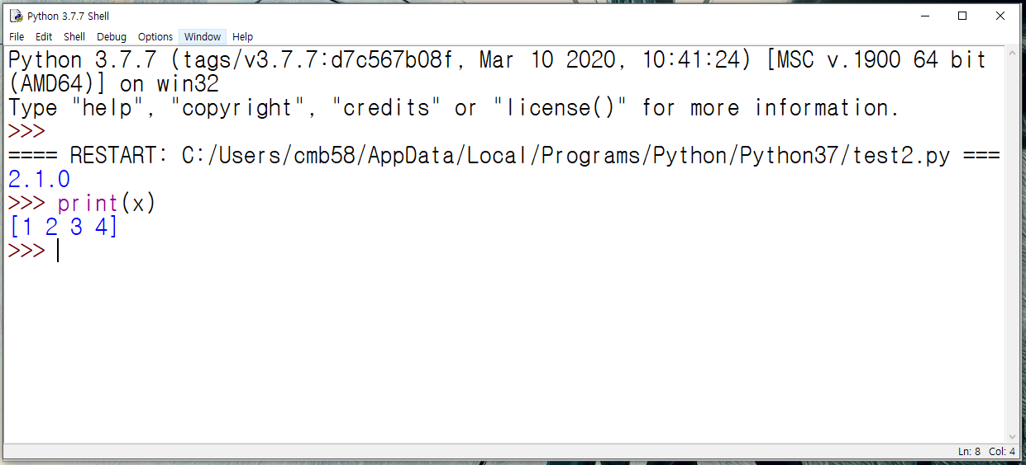

An important note is that when running a certain script you can actually check what information certain variables hold directly through the shell. Meaning that if, for example you are trying to debug by printing out the changes within a variable x (like in the example above, x is a numpy array) then you can directly use the print function within shell and it’ll output the instance of x within the script you are running rather than having to put the actual print line within your script code.

This goes for any classes, methods, variables that you make within your script. Now, although this is great, make sure to remember that running multiple script will override the other scripts ran before, thus you will only be able to check and use the functionalities within your latest ran script.

**[Additional information]** Changing font sizes

You can change font sizes by going to the ‘Options’ section and clicking on ‘Configure IDLE’

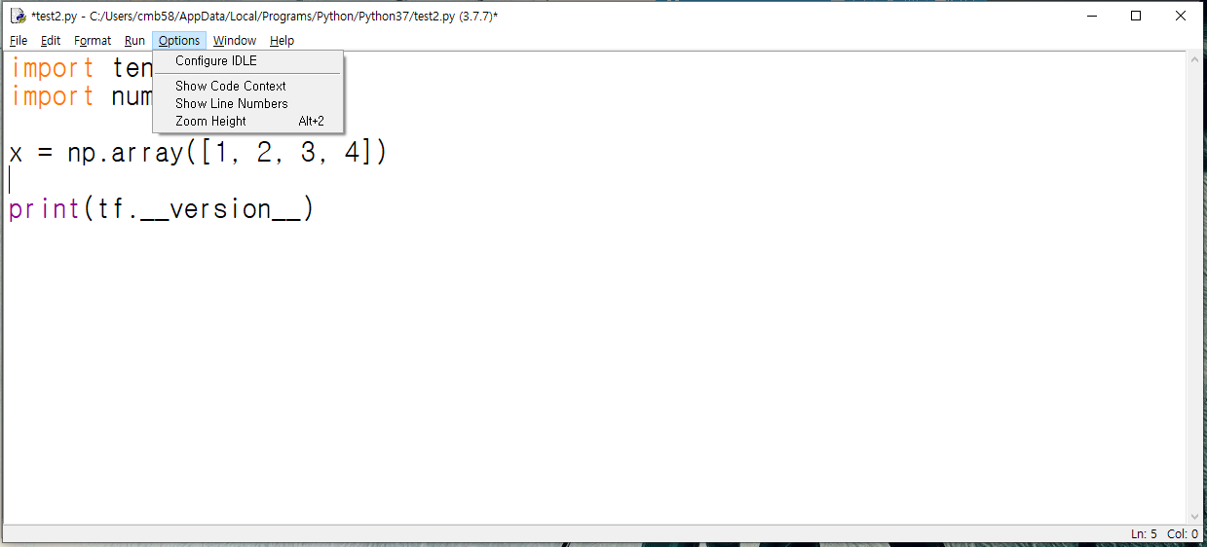

This should then open up a tab which looks like this:

Here you can change both the font and font sizes



Make sure to click apply -> ok when finished

**Using PyCharm IDE only:**

To use this method you **must** install python first.

IDE stands for integrated development environment. For the people who don’t know what this is, it’s a program to write your code in. Now I know what you may be saying. Why use this when we can just use IDLE? Well, IDE’s have extremely helpful functionalities and we’ll check out a few of them after showing you how to install it.

There are many different IDE’s from many different companies for many different languages, however, in this book we will be using PyCharm, which is an IDE that is very popular for developers writing and running code in python

Step 1: Firstly let’s go ahead and download pycharm.

To download pycharm go to jetbrains.com/pycharm/ or you can open the first link after searching up pycharm within your web browser.



Step 2: Now press the black download button in the middle of the website



You should now be redirected to this page



Here there are two versions to download. The professional version is payed with a free trial though and the community version is free. The difference between won’t affect our ability to write and test the codes within this book so you can just download and use the free version.

Step 3: Once you’ve finished downloading the installer, click and run the installer. The installer should look something like the following:

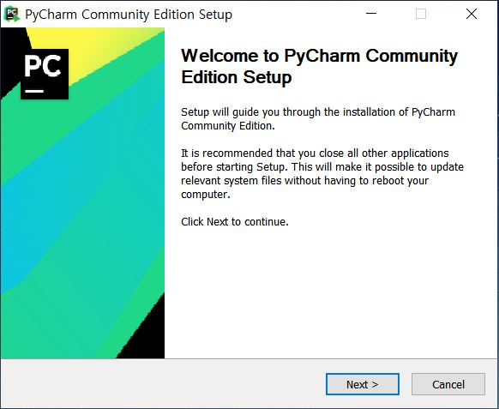

Step 4: From here click next



Step 5: You should’ve arrived at the following, here you can browse to choose the installation location, when finished click next

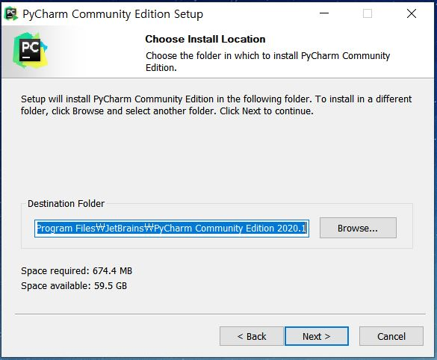

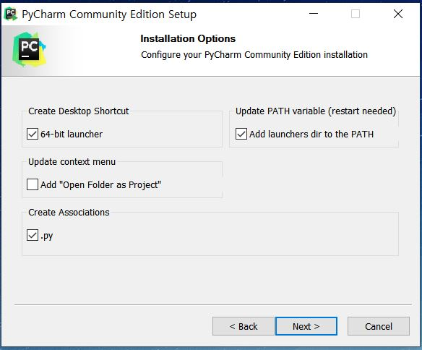Step 6: On this section of the installation it’s recommended the you tick both the ‘Add launchers dir to the PATH’ and the create associations ‘.py’ section. Creating the desktop shortcut is totally up to your personal preferences.

Step 7: This section is also up to personal preferences but normally keeping it its default ‘JetBrains’ name will be fine.

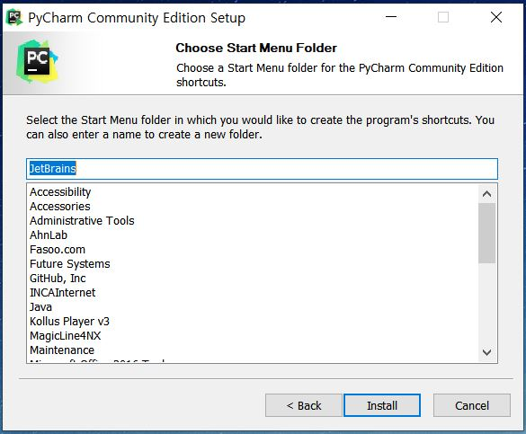

Step 8: You should see the program installing pycharm with a progression bar aswell

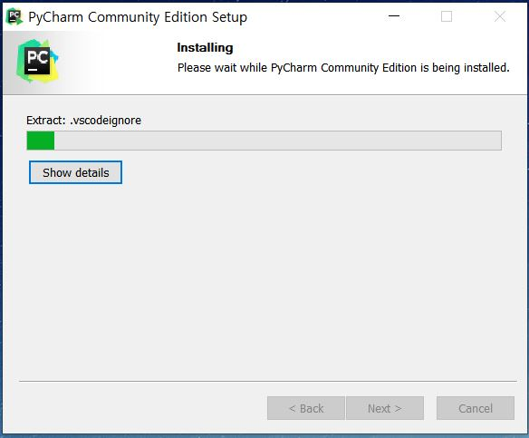

Once finished you’ll be prompted to reboot your system. It’s up to you when to do this; however, you must restart before launching pycharm after installation.

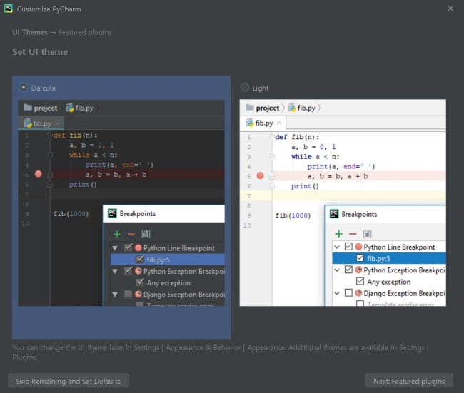Step 9: When opening pycharm for the first time you’ll see the following screen. You can go ahead read the basic tutorial provided by pycharm or you can just skip it.

Step 10: Once finished reading or skipping your screen will look like the following. If you already have a pre-existing folder that you’d like to save your python code in, you can click the ‘Open’ section and browse through your files otherwise click ‘Create New Project’



Step 11: Don’t’ worry about this section if you’re completely new to pycharm. Here you should only worry about the location of your project, thus change the location of your project to your desired place and click create.

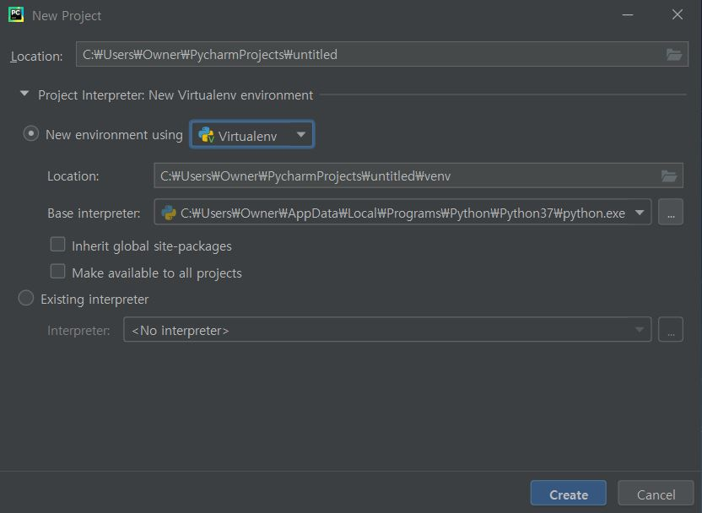

Step 12: After clicking create, your screen should look like the following. At this point pycharm might take a while creating and loading your project, so wait patiently. You’ll be able to see your folder on the left hand side of the screen.

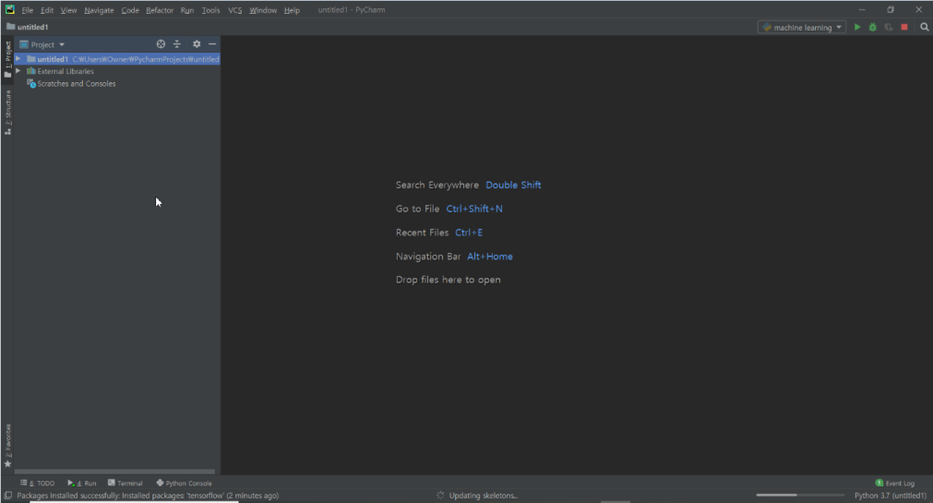

Step 13: To create a new file right click the project folder -> New -> File

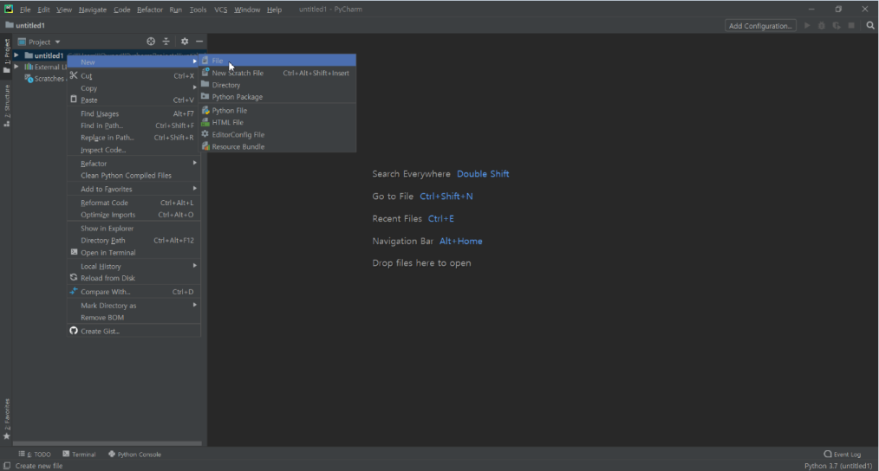

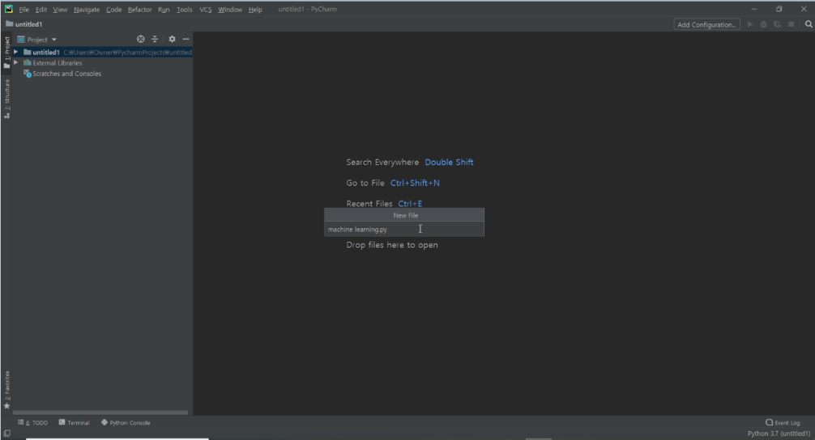Step 13: Create a name for the new file and make sure to use the .py extension

You should now see the new file appear on the left hand side of pycharm and your new python script file should’ve opened

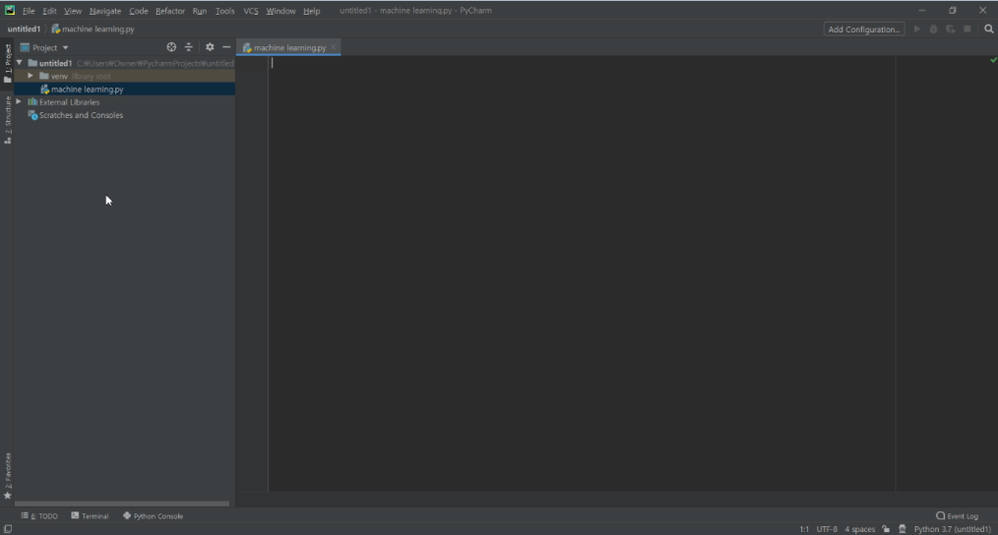

Step 14: Before we can start writing and running our code in pycharm we need to first add configuration. To do this click the ‘Add Configuration’ button on the top right-hand side

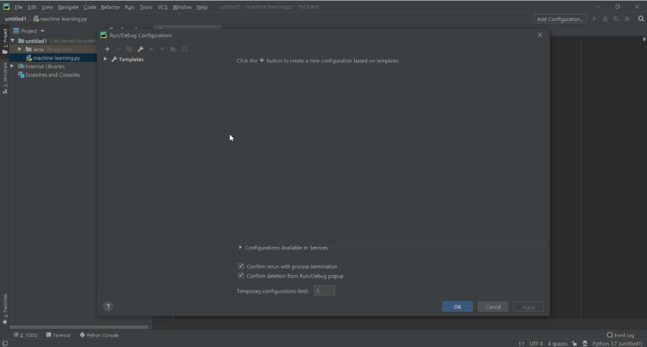Step 15: Something like the following should’ve opened.

Step 15: Here click the plus sign on the top left-hand side and click ‘Python’

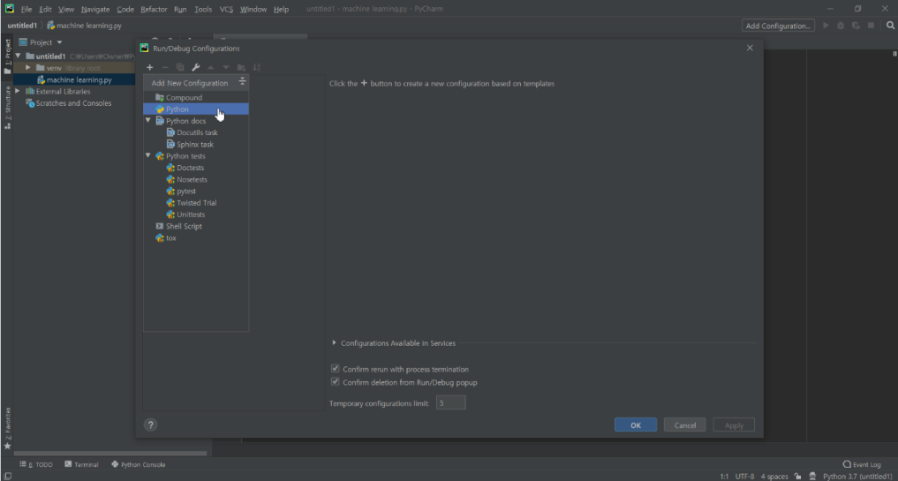

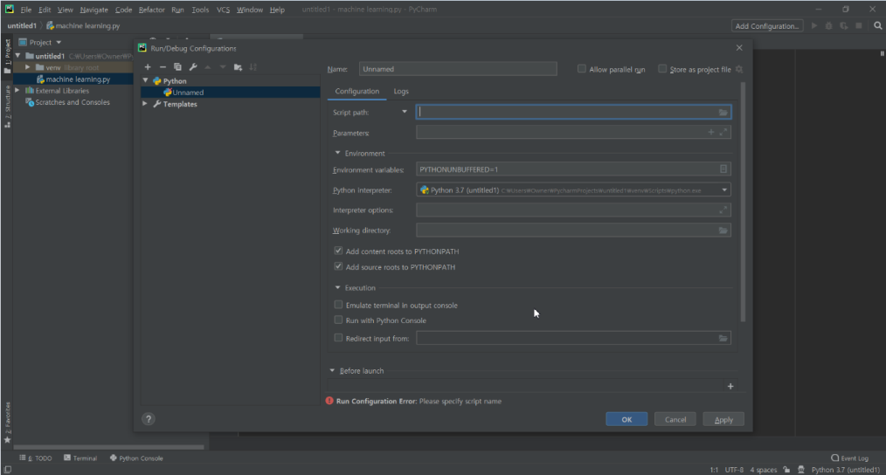Step 16: You should now see the following open up. Here in the ‘Python interpreter’ section python 3.7 should automatically have been chosen for you. If not then click the arrow and choose the version of python that you want to use, once finished press apply -> ok

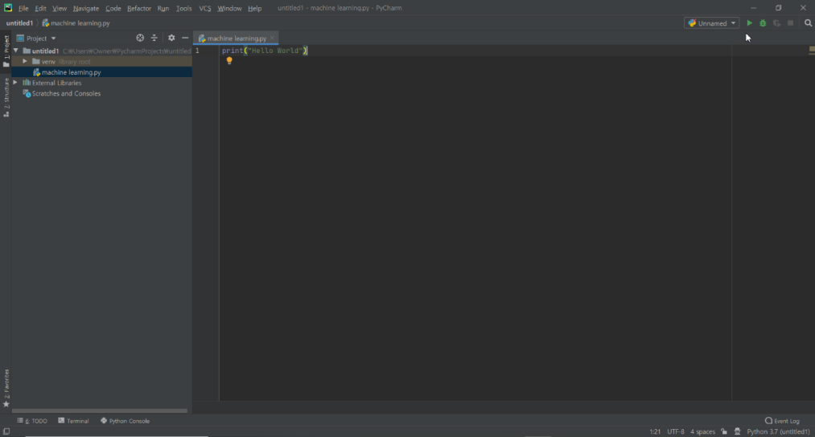Step 17: Once you’ve finished you should now see a play button appear where ‘Add configuration’ was

Step 18: For any script you’ll not be able to simply press the play button to run. You’ll need to right click the file tab and run like the following (This goes for all new scripts).

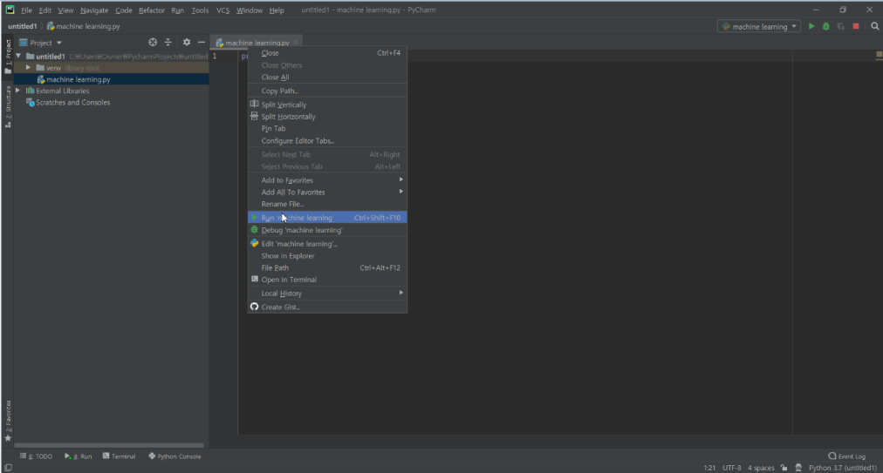

Step 19: Once run, you’ll see the output at the bottom of your screen

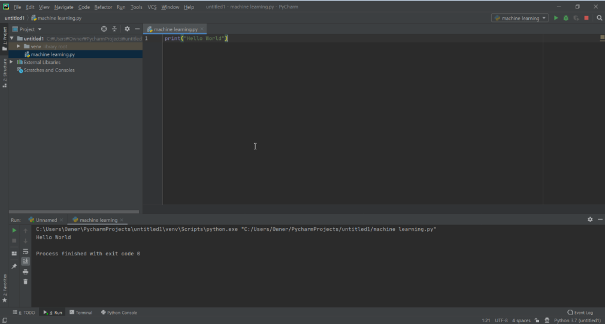

Step 20: Now you’ll need to install tensorflow, to do this go to File -> Settings

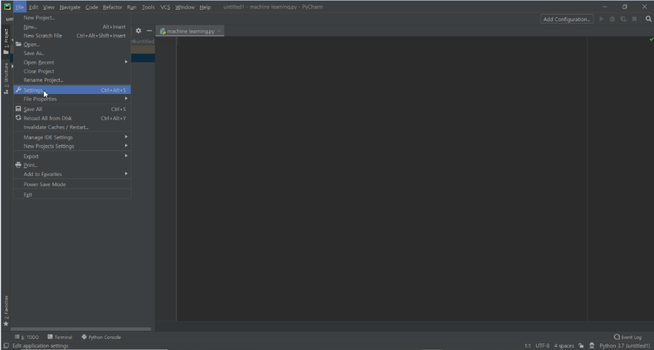

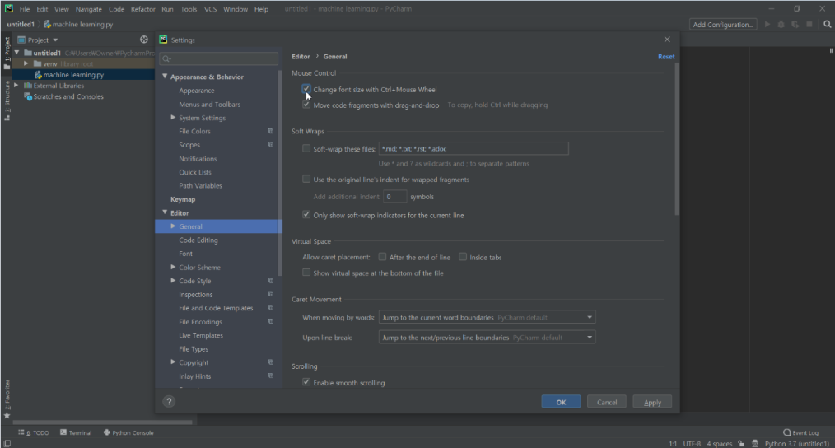**[Additional Information]** There’s a useful setting that you should turn on. Once in the options, go to Editor -> General and check the ‘change font size with Ctrl+Mouse Wheel’.

Step 21: Once you’re in settings, go to Project -> Python interpreter. It should look like the following

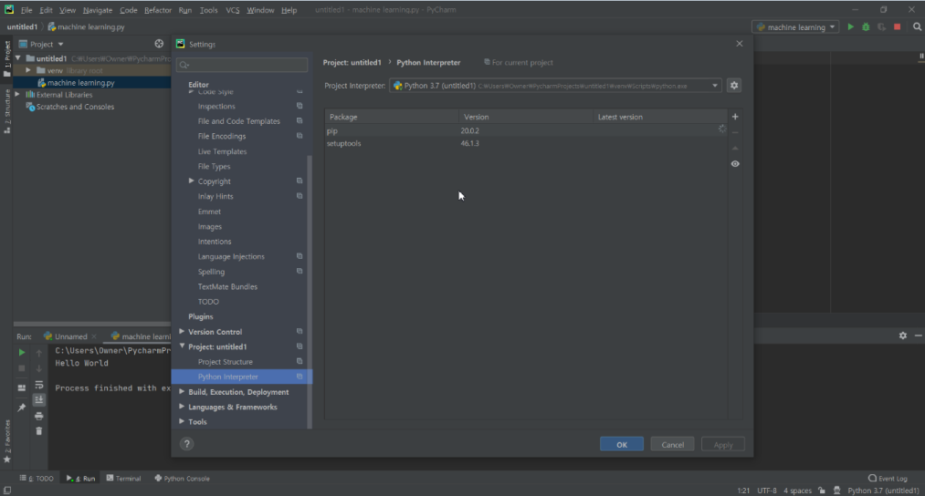

Step 22: Once here click the plus sign on the right-hand side.



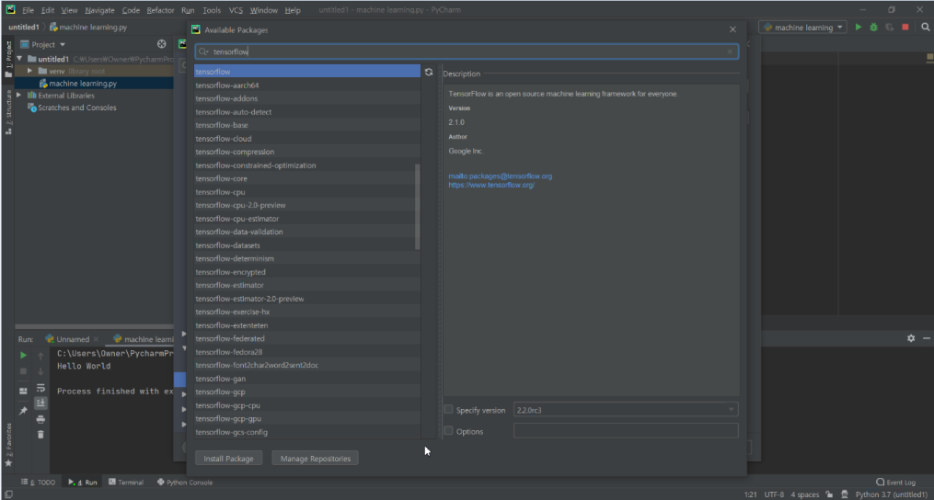Step 22: Once clicking, you’ll see the following screen. In the search bar search up what packages you’d like to install

Step 23: Click the correct package and press ‘install package’



Step 24: After clicking the install button you’ll see at the bottom of you’re a progression bar like the following

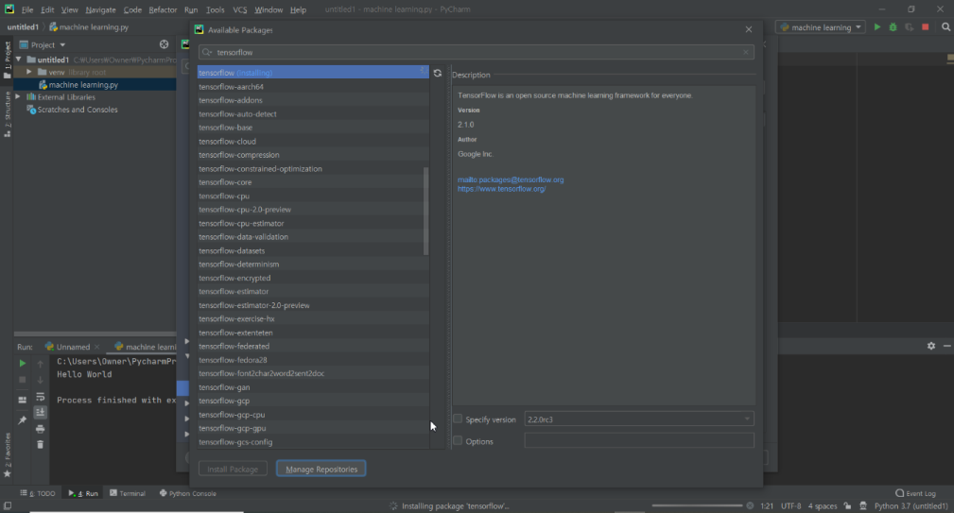

Step 25: Once packages are successfully installed you should see the following green line.

